Property Owner

Mailing Address Email

City , St Zip Phone ( ) -

Project Address

Project Description

Material & Labor Costs Estimate $ Projected start date / /

APPLICATION FEE: $40^{.00} (Check payable to the Town of Canadice or exact cash amount, please) Estimated end date / /

Contractor

Address Email

City , St Zip Phone ( ) -
Workers Compensation Insurance Yes* or CE-200 form*⁺ - WC Exemption Certificate; http://www.wcb.ny.gov

Liability Insurance Certificate Yes* or Not required – Please indicate why not on the back of this application.
* Permits will NOT be issued without required current certificate(s) being submitted with application.
⁺ The CE-200 WC Certificate of Exemption must also be submitted by homeowners who are performing the construction themselves.
This application must be accompanied with:
Specifications about the unit being installed including make, model number, and overall dimensions; and
A general plot and/or floor plan showing the location of the unit(s) and distances from the house, windows, doors, vents, and gas meter or fuel tank(s).

The applicant shall, as part of this application, agree to:
- Have all electrical work inspected by a third party certified electrical inspector and procure a certificate of approval;
- Do not use the installation in whole or in part for any purpose whatsoever until the structure meets all applicable codes and stipulations; all inspections have been made; approvals are granted; and a certificate of compliance is issued.
Per NFPA Part 70 Article 702.8(a) a sign must be clearly posted at the electrical service entrance indicating that a generator is on the premises if one is installed.

The undersigned represents and agrees as condition to the issuance of this permit that said structure shall be constructed in accordance with all laws, ordinances of the Town and the State of New York Uniform Fire and Safety Prevention and Energy Code of the State of New York, and all other applicable laws, codes, and regulations.

Owner / Agent Signature Date / /

OFFICIAL USE ONLY
Code Enforcement Officer Date / /
Town Clerk Date / /
Fee Paid $ District Tax Map ID#
Approved Not approved Plans reviewed by Permit #

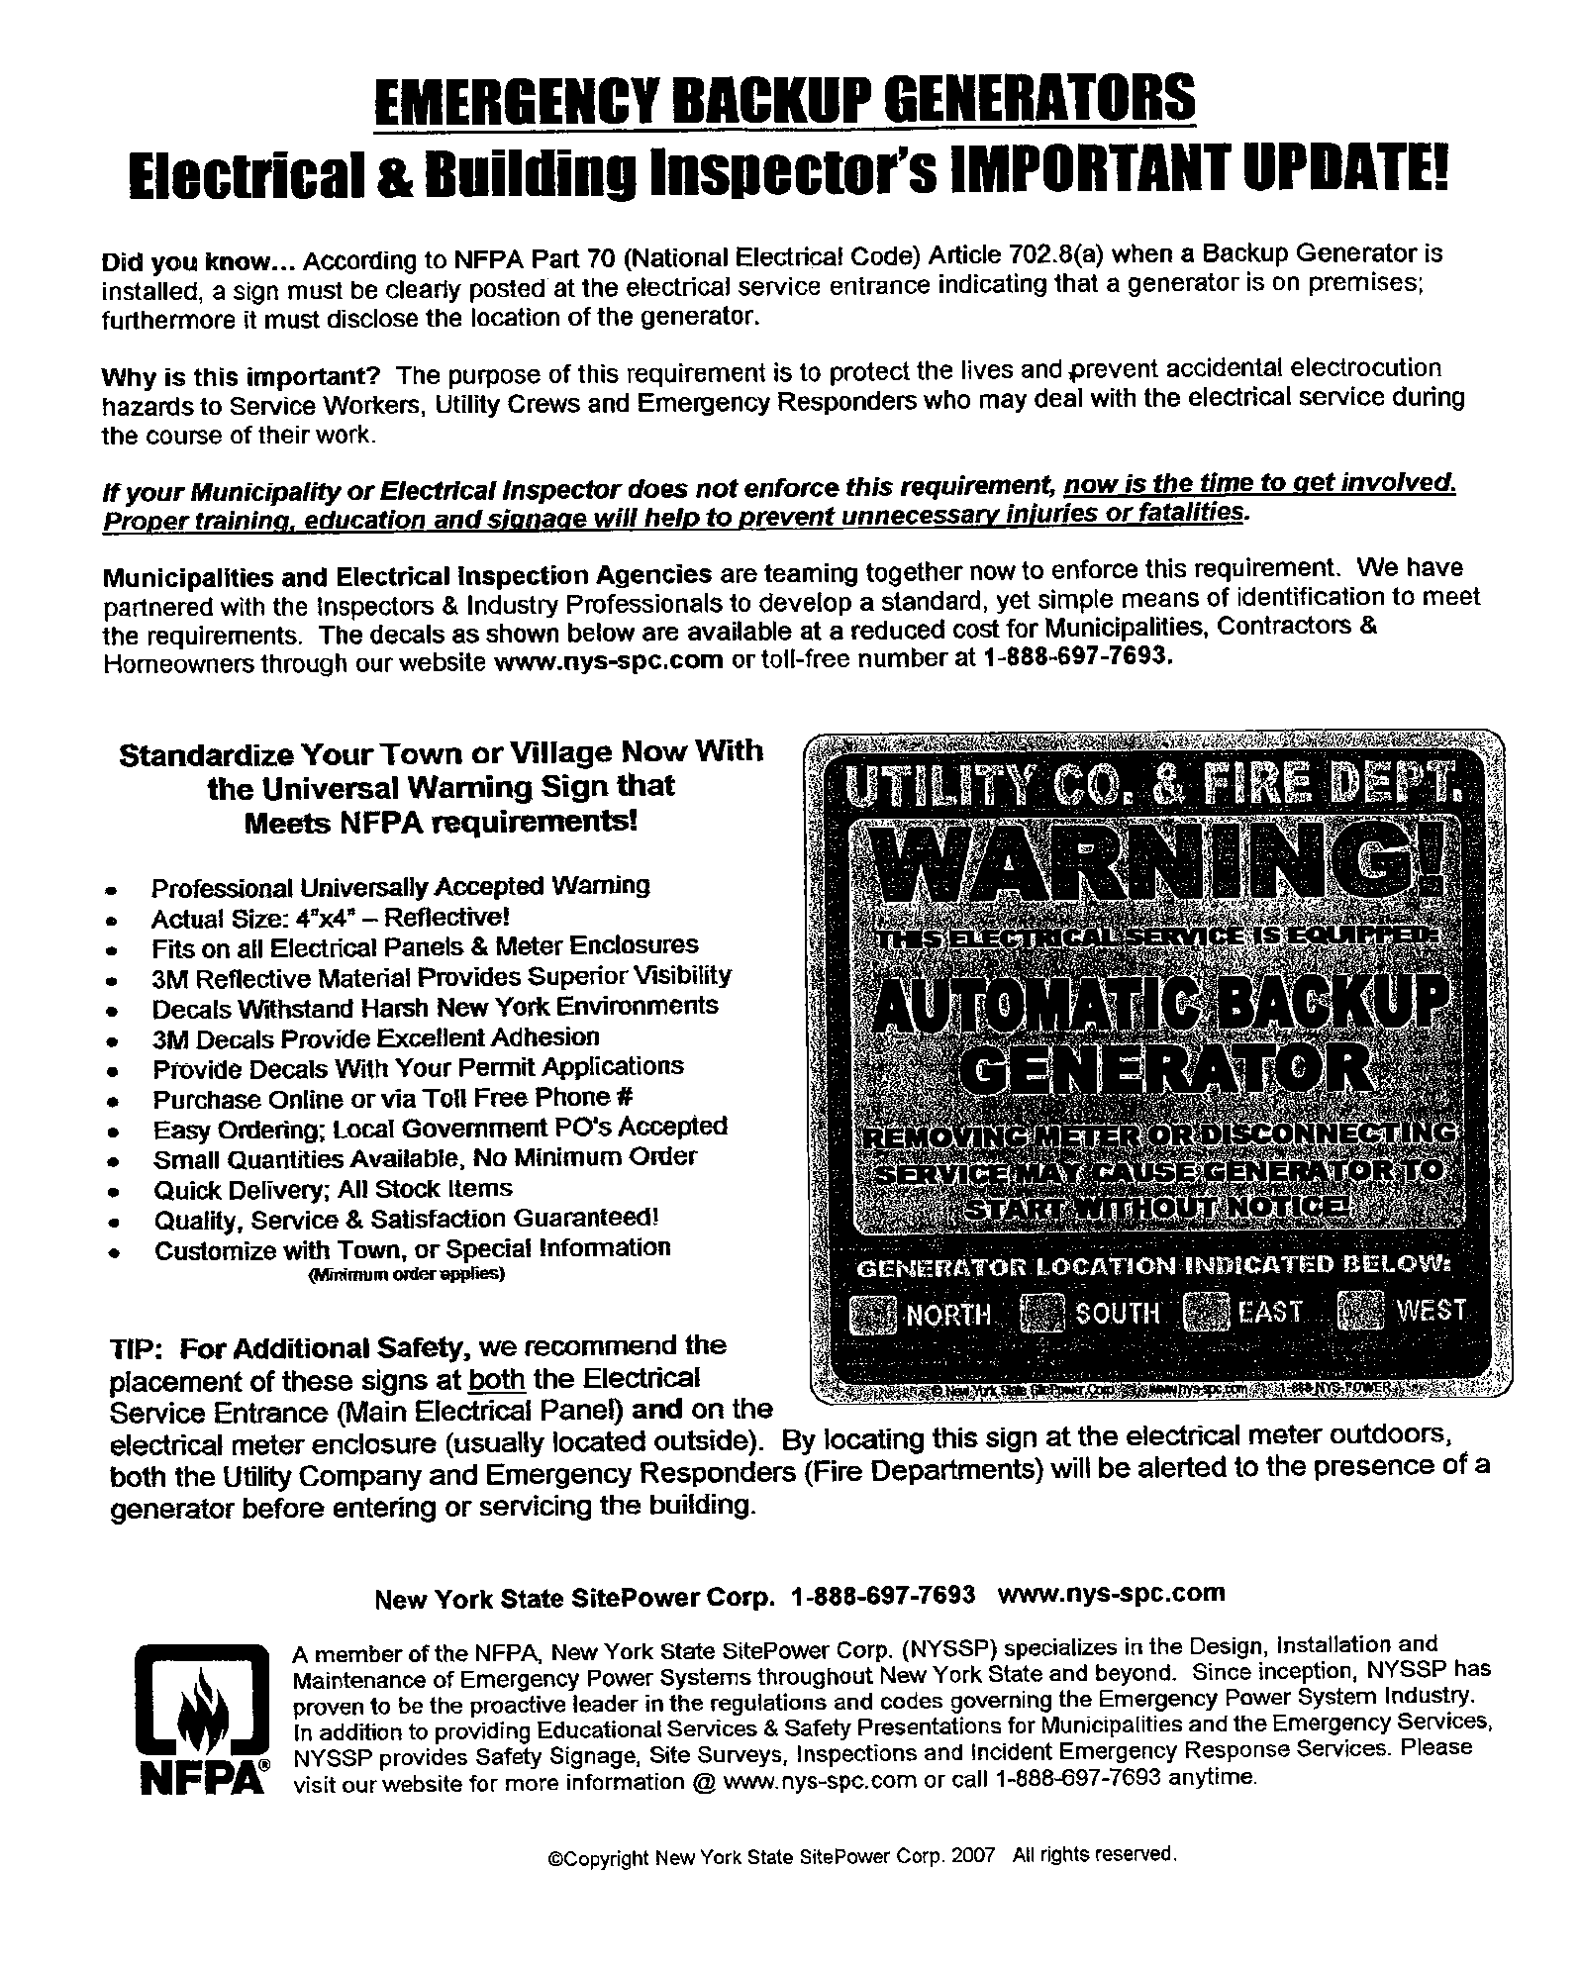

Indicate clearly and distinctly the location of the unit(s) to be installed and distances from the house, windows, doors, vents, and gas meter or fuel tank(s).

Road

