RICHMOND RECREATION
DIY
DOG AGILITY

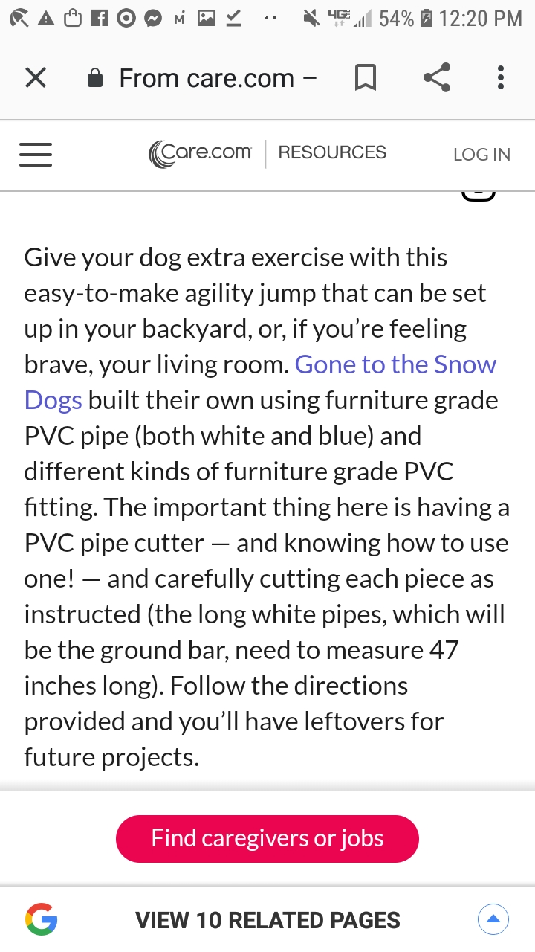

CHECK OUT:
GONE TO THE SNOW DOGS
ON
FACEBOOK & YOUTUBE & INSTAGRAM
FOR MORE PROJECTS & TREATS FOR DOGS

