RICHMOND RECREATION

PAPER AIRPLANE
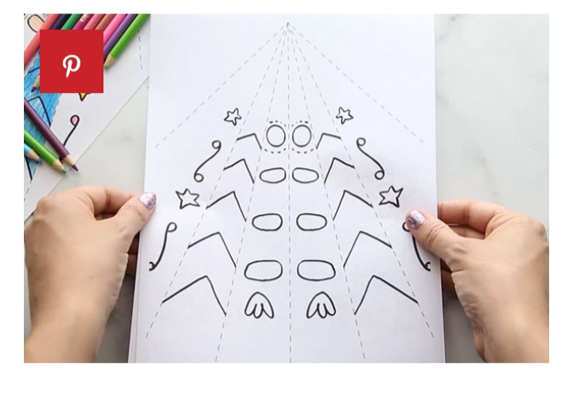

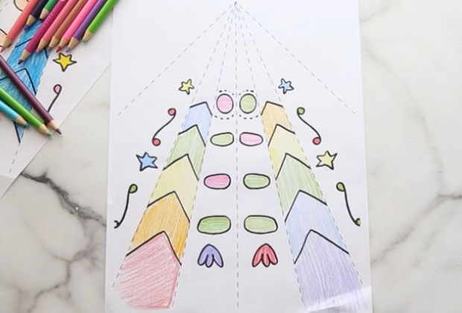
COMPLETE INSTRUCTIONS CAN BE FOUND AT:
WWW.THEBESTIDEASFORKIDS.COM

