Property Owner

Mailing Address

City , NY Zip Phone ( ) -
Project Address

Setbacks: Front Rear Right side Left side
Materials & Labor Costs Estimate $ Work start date / /

Permit fees: $30^{.00} Hot tub; Estimated end date / /
$25^{.00} Storable swimming/wading pool (deeper than 24” and up to 42” depth);
$30^{.00} Above ground swimming pool (deeper than 24”);
$50^{.00} In ground pool. (Cash or check payable to the Town of Canadice) District

Contractor

Address

City , St Zip Phone ( ) -

Workers Compensation Insurance Yes* Not required CE-200 form attached*
Liability Insurance Certificate Yes* Not required
* Current certificates must be on file with the Town of Canadice.

Plans by

Address

City , St Zip Phone ( ) -

The undersigned represents and agrees as condition to the issuance of this permit that said structure shall be constructed in accordance with all laws and ordinances of the Town; the State of New York Uniform Fire and Safety Prevention Code; the Energy Conservation Code of New York State; and all other applicable laws, codes, and regulations.

Owner / Agent Signature Date / /

OFFICIAL USE ONLY
Code Enforcement Officer Date / /
Town Clerk Date / /
Fee Paid $ Permit # Plans approved by
Approved Not approved Tax Map ID No. - -

The applicant and/or contractor assumes responsibility for
- providing a copy of all Operation Manuals;
- providing a copy of all Maintenance Manuals;
- requesting inspections as listed on the Building Permit;
- giving at least 24 hours notice of inspection request; and
- obtaining a certificate of occupancy and/or compliance before use.

Inspections shall be REQUIRED on the following schedule:
- Piping to be concealed in trenches before backfilling;
- Circulation and filtering systems;
- Hydrostatic pressure test (25 psi for not less than 15 minutes);
- Alarms;
- Electrical inspection by a third party certified electrical inspector;
- Decking;
- Barriers (fencing, gates, latches, and/or ladder);
- Final Inspection

NOTICE:

- No structure erected or altered pursuant to this permit, No. shall be occupied for any purpose until a certificate of occupancy and/or compliance has been issued.

Owner / agent signature Date

Rear line _________ ft.

Setback from rear line _________ ft.

Setback from Setback from
side line (A) side line (B)
_________ ft. _________ ft.

Setback from front line _________ ft.

Frontage _________ ft

Street

Resources for installation

2015 Residential Code of New York State
(2015 International Residential Code for One and Two Family Dwellings)
Part VIII, Electrical; Chapter 42. Swimming Pools

2017 Uniform Code Supplement of the NYS Building Standards and Codes
Section R326, Swimming Pools, Spas and Hot Tubs
Note: Includes information on alarms and barriers.

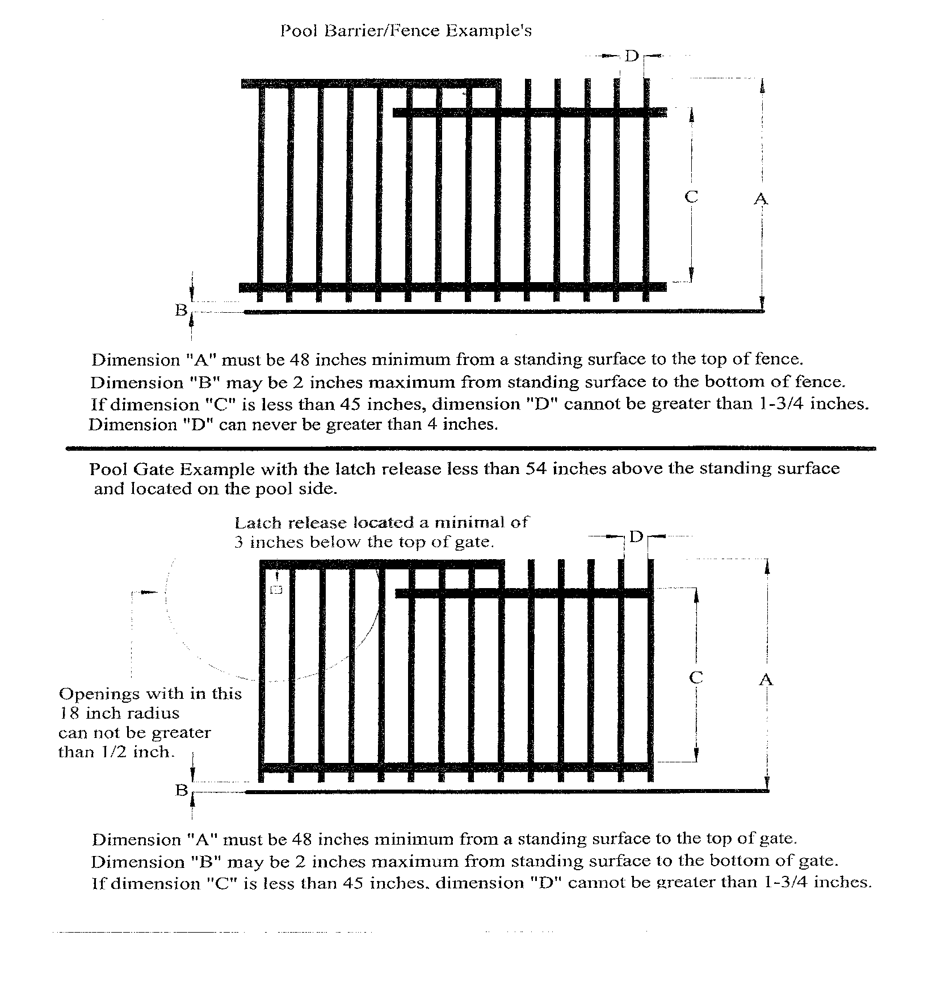
NOTES:
- Gates must be self-closing, self-latching, outward-opening, and lockable.
- The latch handle must be at least 40 inches above grade.
- For other barrier designs and requirements, see the 2017 Uniform Code Supplement of the NYS Building Standards and Codes.

NOTES:
- Every swimming pool or spa that is installed, constructed or substantially modified after December 14, 2006, shall be equipped with an approved pool alarm.
- A pool alarm must be capable of detecting entry into the water at any point. If necessary, more than one pool alarm may be required.
- Pool alarms shall activate upon entry into the water and shall sound poolside and inside the dwelling.
- Pool alarms shall comply with ASTM F2208 (Standard Specification for Pool Alarms.)
- Use of personal immersion alarms do not meet these requirements.
- Exceptions to the above:
  - A hot tub or spa equipped with a safety cover (ASTM F1346); and
  - A swimming pool equipped with a safety cover (ASTM.)
- For more information, see the 2017 Uniform Code Supplement of the NYS Building Standards and Codes.

