RICHMOND RECREATION
BUILD A BEAR
PET PAGE
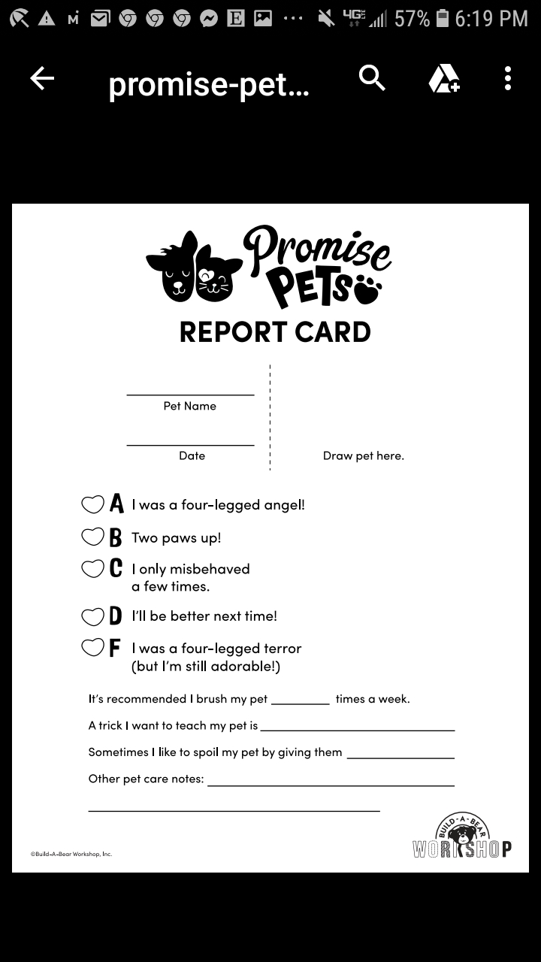
FOR MORE INFO.
WWW.BUILDABEAR.COM
CLICK ON GAMES THEN SCROLL DOWN TO ACTIVITIES
EVERY WEDNESDAY NEW ACTIVITIES

