RICHMOND RECREATION
BUILD A BEAR
SANDWICH
SUPPLIES:
-BREAD
-CHEESE
-BLUEBERRIES
-OR WHATEVER YOU WOULD LIKE ON YOUR SANDWICH

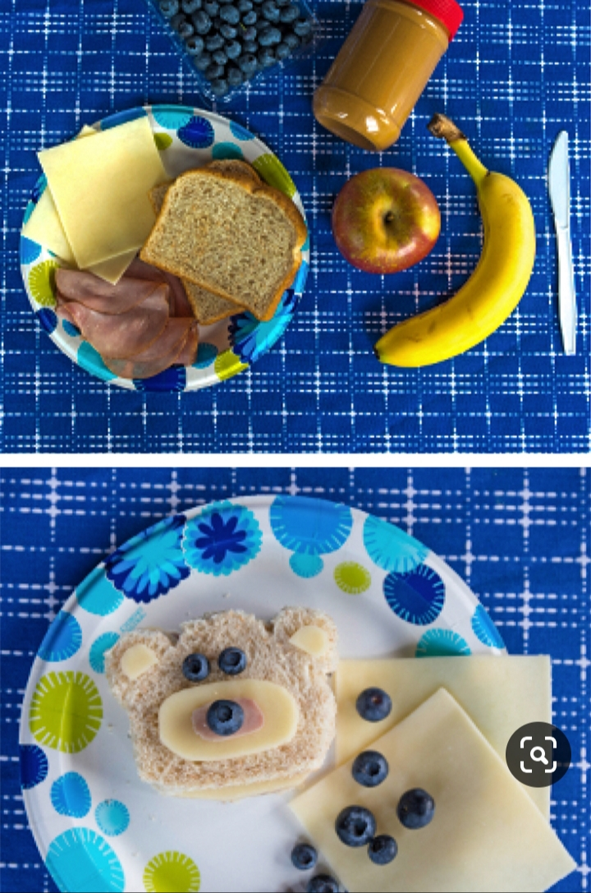

COMPLETE INSTRUCTIONS CAN BE FOUND AT:
WWW.BUILDABEAR.COM
ALONG WITH STORYTIME ABOUT A MERMAID BEAR

