RICHMOND RECREATION
MINI LID BANJOS

SUPPLIES:
-JUMBO CRAFT STICKS
-LOOM BANDS
-WASHI TAPE
-DUCT TAPE
-SEQUINS
-GLUE

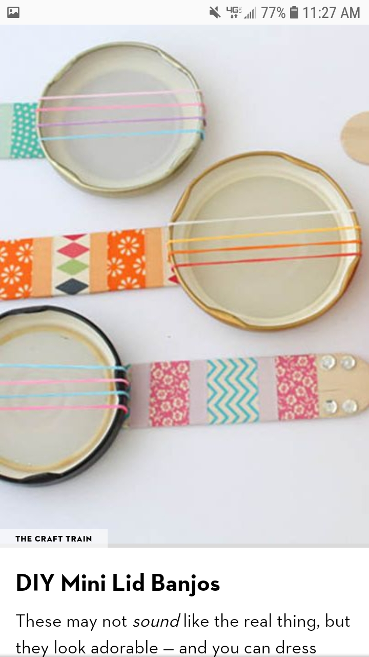
DETAILED INSTRUCTIONS
CAN BE FOUND AT:
WWW.THECRAFTTRAIN.COM

