RICHMOND RECREATION
EASTER CRAFT EDITION:
EASTER PAPER PLATE BASKET:
SUPPLIES:
-2 PAPER PLATES
-ANY COLOR PAINT
-ANY COLOR CARDSTOCK OR CONSTRUCTION PAPER
-RIBBON FOR HANDLE
-GLUE
-EASTER GRASS FILLING
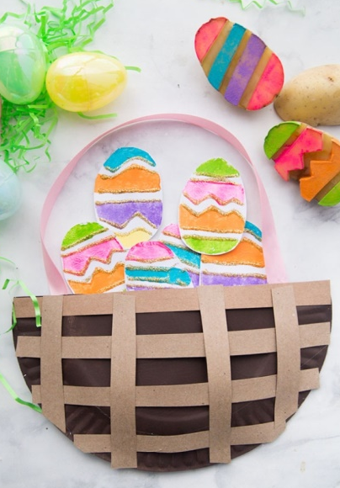
POTATO STAMPED EASTER EGGS:
(PICTURED ABOVE WITH BASKET)
SUPPLIES:
-DIFFERENT COLORS OF PAINT
-WHITE PAPER OR CARDSTOCK OR CONSTRUCTION PAPER
ONCE FINISHED WITH THE EGGS YOU CAN PUT THEM IN THE PAPER PLATE EASTER BASKET!
0NLINE VIDEOS OF ALL CRAFTS SHOWN CAN BE FOUND AT: WWW.THEBESTIDEASFORKIDS.COM

