RICHMOND RECREATION
BEAN BAG TOSS
SUPPLIES:
-LADDER
-PAPER
-MARKER
-TAPE
-BEAN BAGS

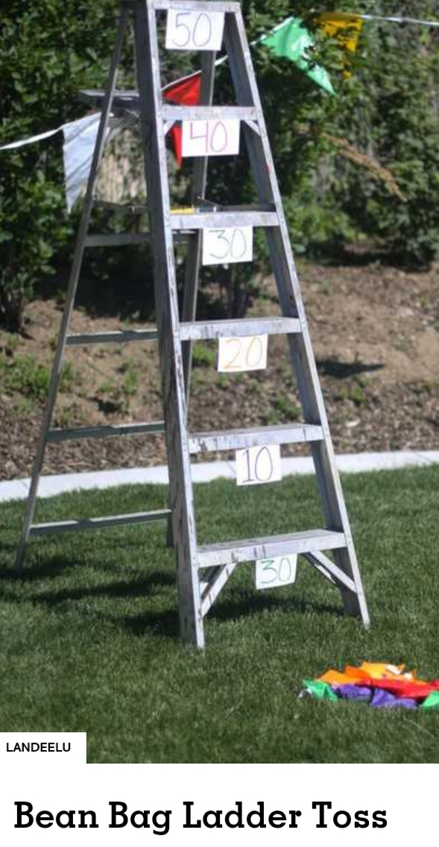
BEAN BAGS CAN EASILY BE MADE OUT OF A PLASTIC ZIP LOCKING BAG WITH RICE OR BEANS IN IT. JUST MAKE SURE THEY ARE SEALED WELL. YOU CAN ALSO MAKE THEM OUT OF FABRIC AND FILL THEM WITH BEANS OR RICE FOR THE GAME.

