RICHMOND RECREATION
BOTTLE CAP BUGS

SUPPLIES:
-BOTTLE CAPS
-SHARPIE MARKERS
-SCISSORS
-GLUE
-TRANSPARENCY PAPER
-GOOGLY EYES (OPTIONAL)

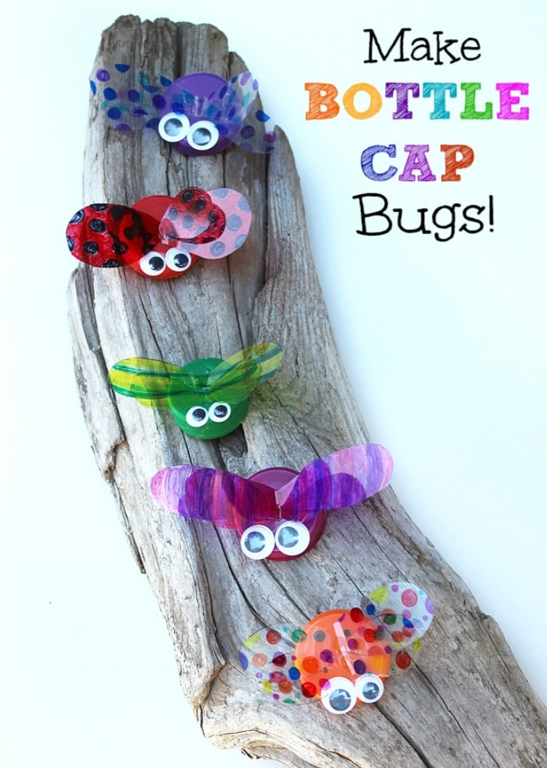
DIRECTIONS:
-COLOR & DESIGN WINGS OUT OF TRANSPARENCY PAPER WITH THE MARKERS
-GLUE WINGS ONTO CAP
-GLUE GOOGLY EYES ON FRONT OF THE CAP
-BOTTLE CAPS CAN BE FROM POP BOTTLES, JUICE BOTTLES, ETC.

