RICHMOND RECREATION
POPPED BUBBLE ART
SUPPLIES:
-BUBBLE MIX
-BUBBLE WANDS
-FOOD COLORING
-PAPER
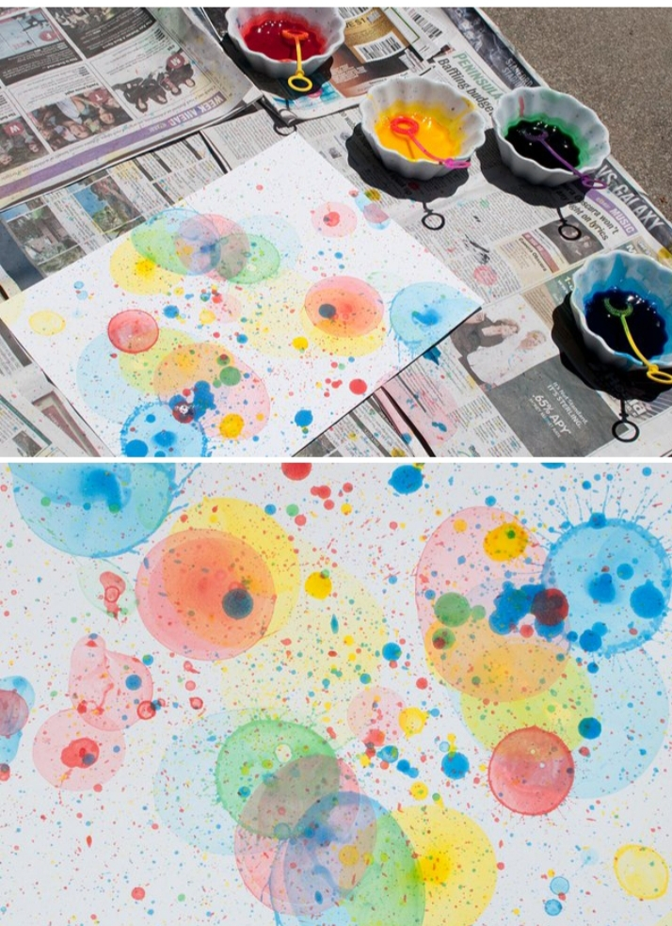

INSTRUCTIONS:
-POUR 1 TABLESPOON OF BUBBLE MIX INTO SMALL, SHALLOW BOWL
-ADD FEW DROPS OF FOOD COLORING INTO THE BUBBLE MIX & STIR WELL
-PLACE YOUR BUBBLE WAND IN THE COLORED BUBBLE MIX, REMOVE & BLOW BUBBLES TOWARDS YOUR PAPER
-AS BUBBLES HIT THE PAPER & POP THEY LEAVE AN INTERESTING PATTERNS, REPEAT WITH OTHER COLORS
FYI:
FOOD COLORING STAINS SURFACES AND CLOTHING, SO BE CAREFUL & TRY PROJECT ON A NON-WINDY DAY OR THE PROJECT BECOMES FRUSTRATING
MORE PROJECTS CAN BE FOUND AT: WWW.BROOGLY.COM

