RICHMOND RECREATION
COFFEE FILTER BUTTERFLY
SUPPLIES:
-COFFEE FILTERS
-PAINT OR MARKERS
-PIPE CLEANERS
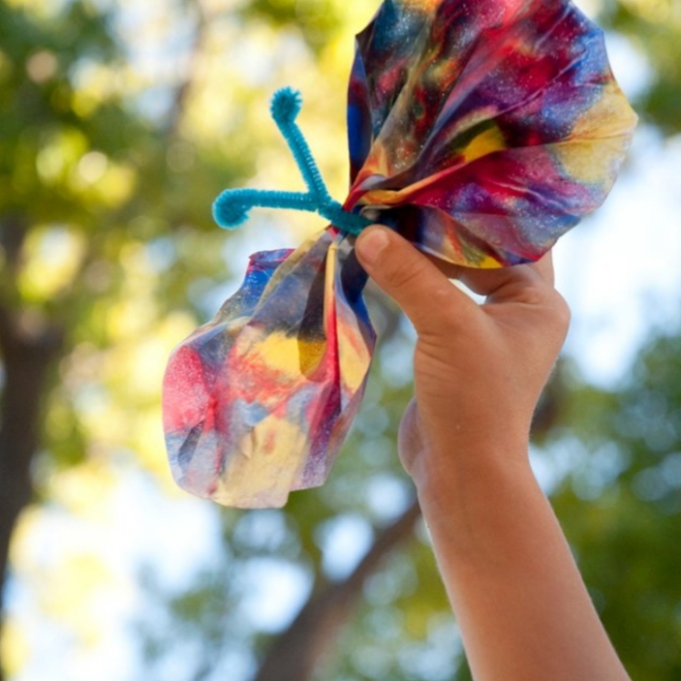

INSTRUCTIONS:
-FOLD FILTER IN HALF
-PLACE DROPS OF PAINT ALL OVER HALF THE FILTER
-FOLD FILTER IN HALF & RUB OVER THE SURFACE TO SPREAD & MIX THE DROPS OF PAINT
-OPEN FILTER & LET DRY
-FOLD THE BUTTERFLY STYLE OF A FAN
-HOLDING THE CENTER OF BUTTERFLY, FOLD THE PIPE CLEANER OVER THE CENTER OF THE BUTTERFLY, TWIST A COUPLE OF TIMES TO SECURE, PULL APART THE 2 ENDS OF PIPE CLEANER & ROLL ENDS SLIGHTLY TO FORM ATTANAE
-CAREFULLY SPREAD WINGS OF BUTTERFLY
TIPS:
-SMALL KIDS WILL NEED HELP WITH THE PIPE CLEANER
-INSTEAD OF PAINT YOU CAN USE MARKERS

MORE PROJECTS CAN BE FOUND AT:
WWW.BROOGLY.COM

