RICHMOND RECREATION
EASTER CRAFT EDITION:
COTTONBALL BUNNY:
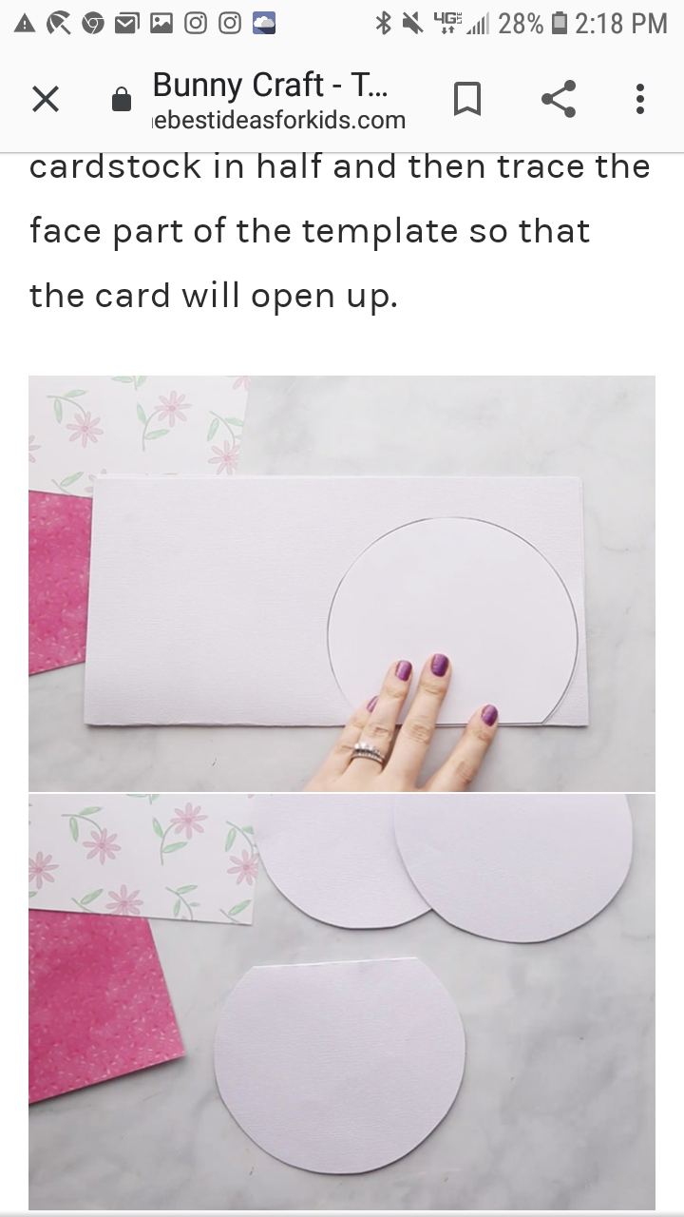

ONLINE VIDEOS OF ALL CRAFTS SHOWN CAN BE FOUND AT: WWW.THEBESTIDEASFORKIDS.COM

