RICHMOND RECREATION
WHITE CRAYON SURPRISE PICTURE
SUPPLIES:
-PAPER
-WATERY PAINT
-WHITE CRAYON
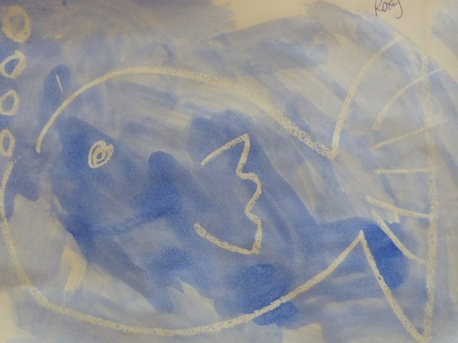

INSTRUCTIONS:
-DRAW A PICTURE IN WHITE CRAYON ON WHITE PAPER, IT CAN BE A SIMPLE PICTURE OR YOU CAN WRITE SOMETHING LIKE YOUR NAME
-BRUSH WATERY PAINT OVER PICTURE

MORE PROJECTS CAN BE FOUND AT:
WWW.BROOGLY.COM

