RICHMOND RECREATION
PUMPKIN SEED CRAFTS
DECORATE A PUMPKIN WITH PUMPKIN SEEDS
SUPPLIES:
-PAINT & BRUSH
-DRY PUMPKIN SEEDS
-GLUE
-PUMPKIN OR FAUX PUMPKIN

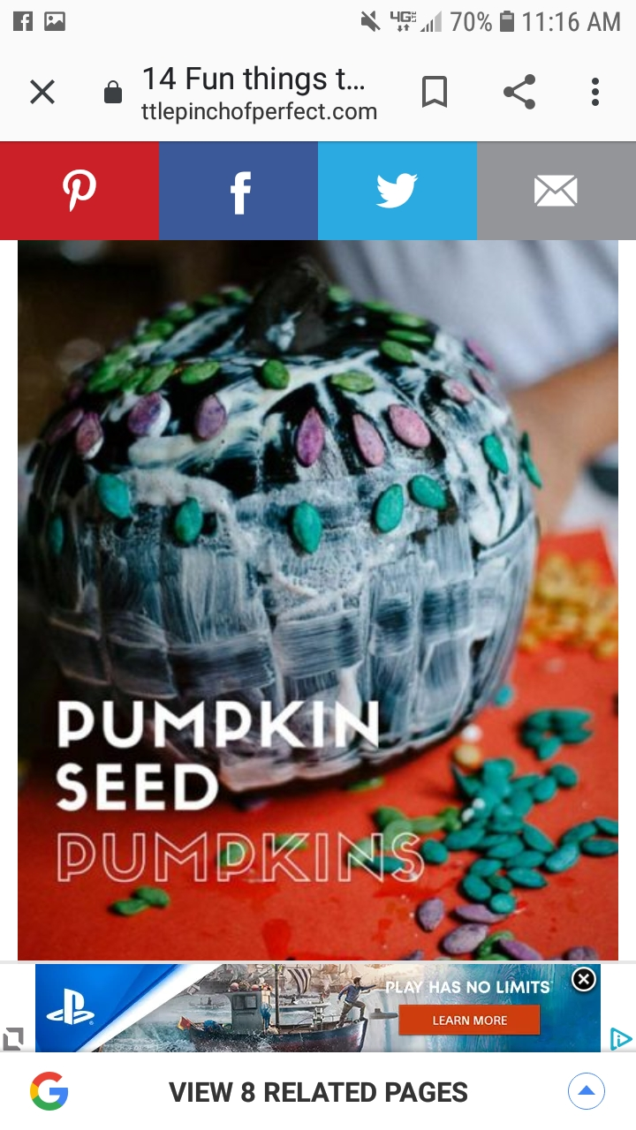

COMPLETE INSTRUCTIONS CAN BE FOUND AT:
WWW.ALITTLEPINCHOFPERFECT.COM

