RICHMOND RECREATION
HATCHING DINOSAUR EGGS
SUPPLIES:
-1 CUP SALT
-1 CUP WATER
-1/2 CUP OF SAND IS OPTIONAL
-2 ½ CUPS OF FLOUR
-2CUPS OF COFFEE GRINDS OR GROUNDS
-GREASE PROOF PAPER FOR BAKING TRAY
-PAINT
-SMALL PLASTIC DINOSAURS

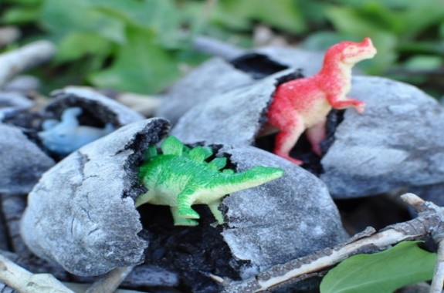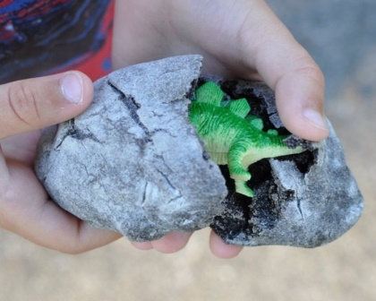
INSTRUCTIONS:
-PRE-HEAT OVEN AT 250 DEGREES
-MIX COFFEE, WATER, 2 CUPS OF FLOUR & SALT IN LARGE MIXING BOWL
- (IF DESIRED ADD SAND)
-FORM A SMALL AMOUNT OF MIXTURE INTO A BALL & THEN FLATTEN INTO DISC SHAPE, PLACE DINOSAUR IN MIDDLE, COMPLETELY COVER, FORM MIXTURE INTO AN EGG SHAPE
-PLACE ON BAKING TRAY
-BAKE EGGS IN OVER FOR 40MINUTES, TURN EGGS & RETURN TO OVERN FOR ANOTHER 40 MINUTES
-REMOVE FROM OVEN & ALLOW TO COOL
-LEAVE FOR AT LEAST 24 HOURS TO COOL & HARDEN
-HIDE EGGS FOR KIDS TO FIND
-EGGS SHOULD BE EASY FOR KIDS TO OPEN

MORE PROJECTS CAN BE FOUND AT:
WWW.BROOGLY.COM

