RICHMOND RECREATION

DINO PAPER PLATES
SUPPLIES:
-PAPER
-SCISSORS
-PENCIL
-GLUE
-MARKERS
-PAPER PLATES
-CLOTHESPIN
-PAINT
-PAINTBRUSH
-CONSTRUCTION PAPER
-GLITTER GLUE OPTIONAL

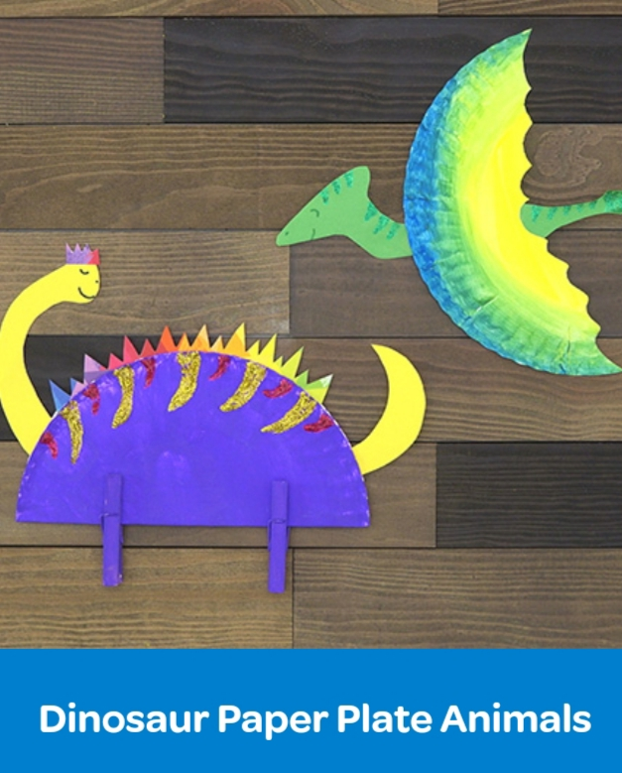

COMPLETE INSTRUCTIONS CAN BE FOUND AT:
WWW.CRAYOLA.COM
UNDER TRENDING CRAFTS

