RICHMOND RECREATION
CREATE MAGIC MOMENTS WITH DISNEY
EVERY FRIDAY NEW ACTIVITIES ARE POSTED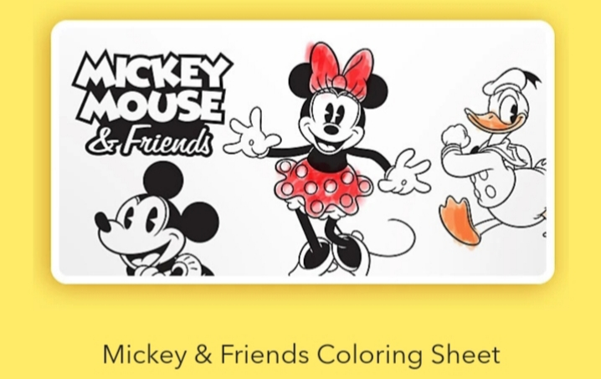
GO TO: WWW.SHOPDISNEY.COM
FROM THERE YOU FIND THE SECTION CREATE MAGIC MOMENTS WITH DISNEY AND BE ABLE TO DOWNLOAD THE COLORING SHEETS

