RICHMOND RECREATION
DIY HALLOWEEN COSTUMES
ARTHUR COSTUME
SUPPLIES:
-EARS
-GLASSES
-YELLOW SWEATER OR TOP
-PANTS
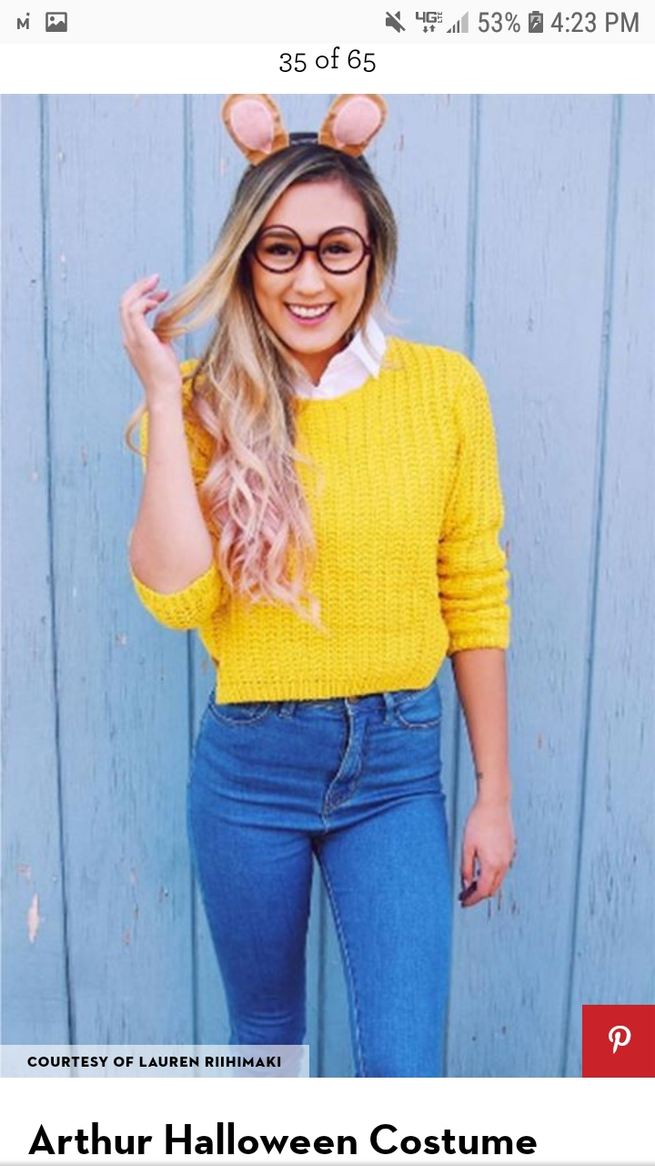

COMPLETE INSTRUCTIONS CAN BE FOUND AT:
WWW.GOODHOUSEKEEPING.COM

