RICHMOND RECREATION
DIY HALLOWEEN COSTUMES
BAT COSTUME
SUPPLIES:
-OLD OR NEW OR BROKEN UMBRELLA
-BLACK HOODIE & PANTS
-HEADBAND
-FOAM & FEATHERS FOR TEXTURE ON EARS FOR THE HEADBAND
-BLACK ELECTRICAL TAPE
-SAFETY PINS OR HOT GLUE
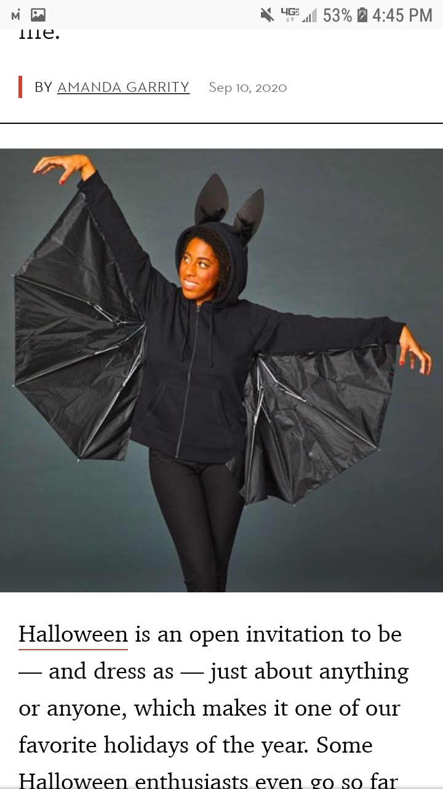
-CUT UMBRELLA IN HALF; USE SAFETY PINS OR HOT GLUE TO ATTACH UMBRELLA TO THE ARMS OF THE BLACK HOODIE. FASTEN HINGES OF METAL UMBRELLA PIECES WITH BLAC ELECTRICAL TAPE SO THEY CAN FOLD PROPERLY
*THIS REQUIRES ADULT SUPERVISION*

COMPLETE INSTRUCTIONS CAN BE FOUND AT:
WWW.GOODHOUSEKEEPING.COM

