RICHMOND RECREATION
DIY HALLOWEEN COSTUMES
CACTUS COSTUME
SUPPLIES:
-GREEN DRESS OR SHIRT & PANTS
-FAUX FLOWERS
-YARN
-SCISSORS
-SEWING NEEDLE & THREAD OR FABRIC GLUE
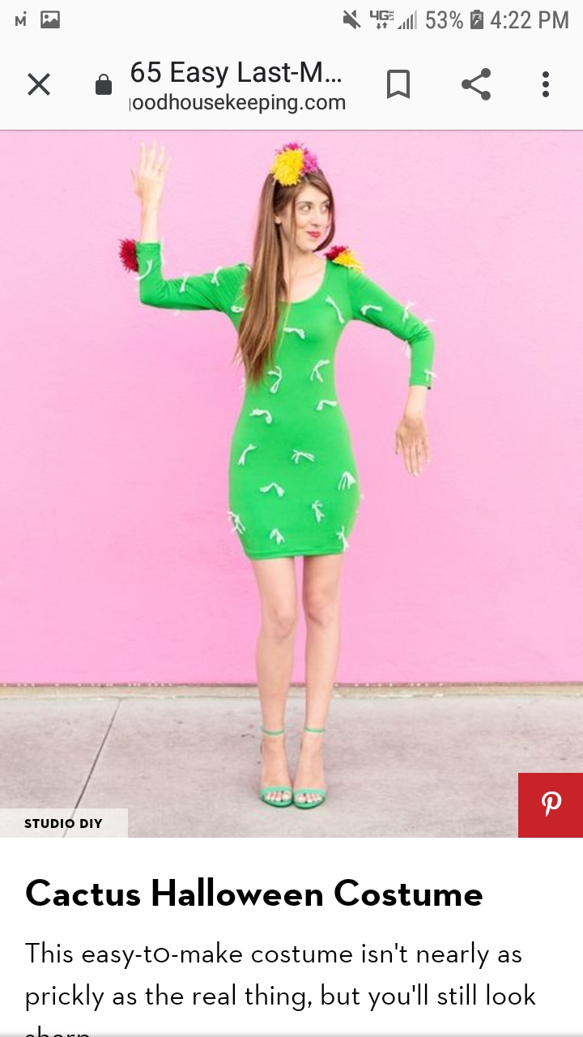

COMPLETE INSTRUCTIONS CAN BE FOUND AT:
WWW.GOODHOUSEKEEPING.COM

