RICHMOND RECREATION
DIY HALLOWEEN COSTUMES
DIY MINNIE MOUSE COSTUME
SUPPLIES:
-BLACK TOP
-BLACK LEGGINGS
-RED TULLE SKIRT
-YELLOW SHOES
SKIRT:
-BLACK FELT OR PAPER FOR DOTS
-DOUBLE SIDED TAPE FOR THE DOTS ON THE SKIRT
EARS:
-HEADBAND
-PAPER OR FELT FOR EARS
-RED BOW
-SCISSORS
-GLUE

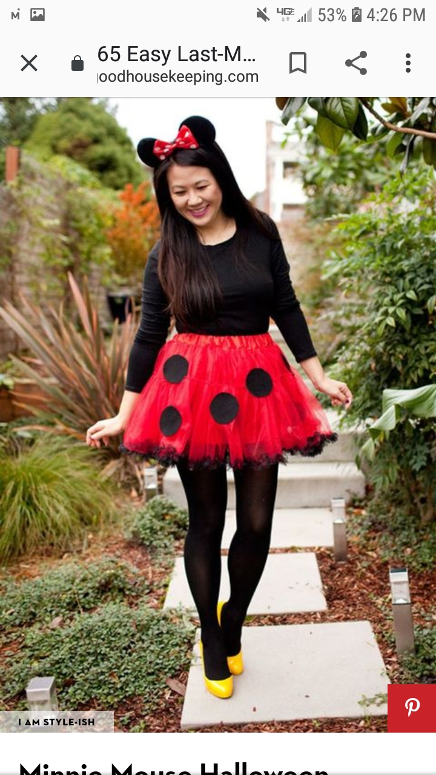

COMPLETE INSTRUCTIONS CAN BE FOUND AT:
WWW.GOODHOUSEKEEPING.COM

