RICHMOND RECREATION
DIY HALLOWEEN COSTUMES
CLOUD & RAINBOW COSTUME
SUPPLIES:
- MULTI-COLORED CONSTRUCTION PAPER
-CARDBOARD BOX FOR RAINBOW
-POLYSTER BATTING FOR UMBRELLA FOR THE CLOUD
-SCISSORS
-GLUE
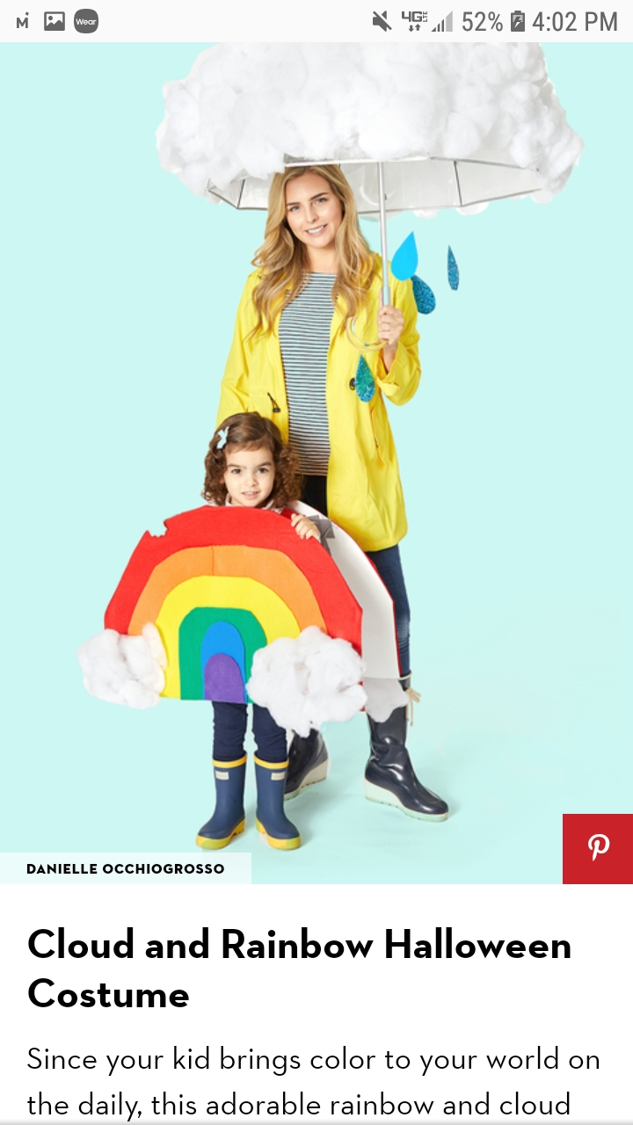

COMPLETE INSTRUCTIONS CAN BE FOUND AT:
WWW.GOODHOUSEKEEPING.COM

