RICHMOND RECREATION
DIY HALLOWEEN COSTUMES
SKELETON COSTUME
SUPPLIES:
-WHITE SHIRT
-BLACK SHIRT
-PINK HEART OR ANY COLOR
-PAPER/FELT OR IRON ON MATERIAL FOR HEART
-FACE PAINT
-SCISSORS
-DOUBLE SIDED TAPE IF YOU USE FELT OR PAPER FOR HEART
-IRON IF YOU USE IRON ON MATERIAL FOR HEART

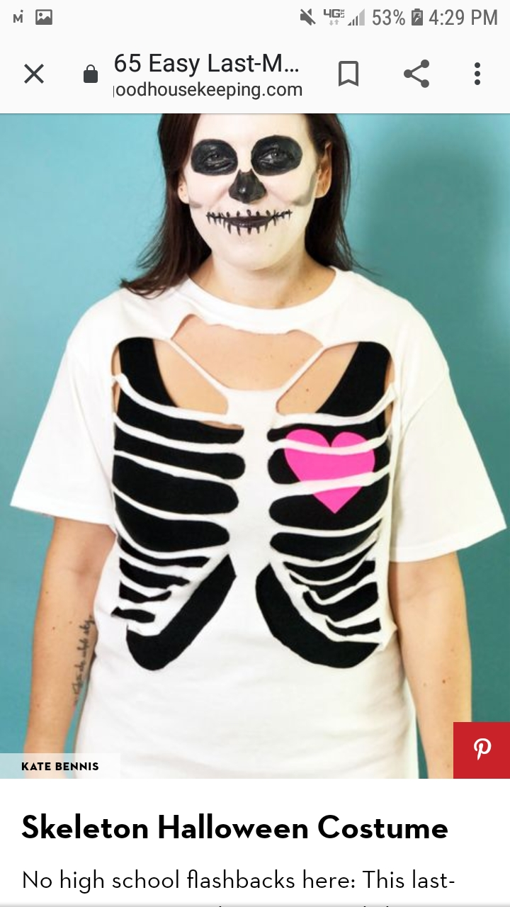

COMPLETE INSTRUCTIONS CAN BE FOUND AT:
WWW.GOODHOUSEKEEPING.COM

