RICHMOND RECREATION
DIY HALLOWEEN COSTUMES
SMARTY PANTS COSTUME
SUPPLIES:
-SMARTIES CANDY
- GLUE DOTS OR DOUBLE SIDED TAPE
-PANTS
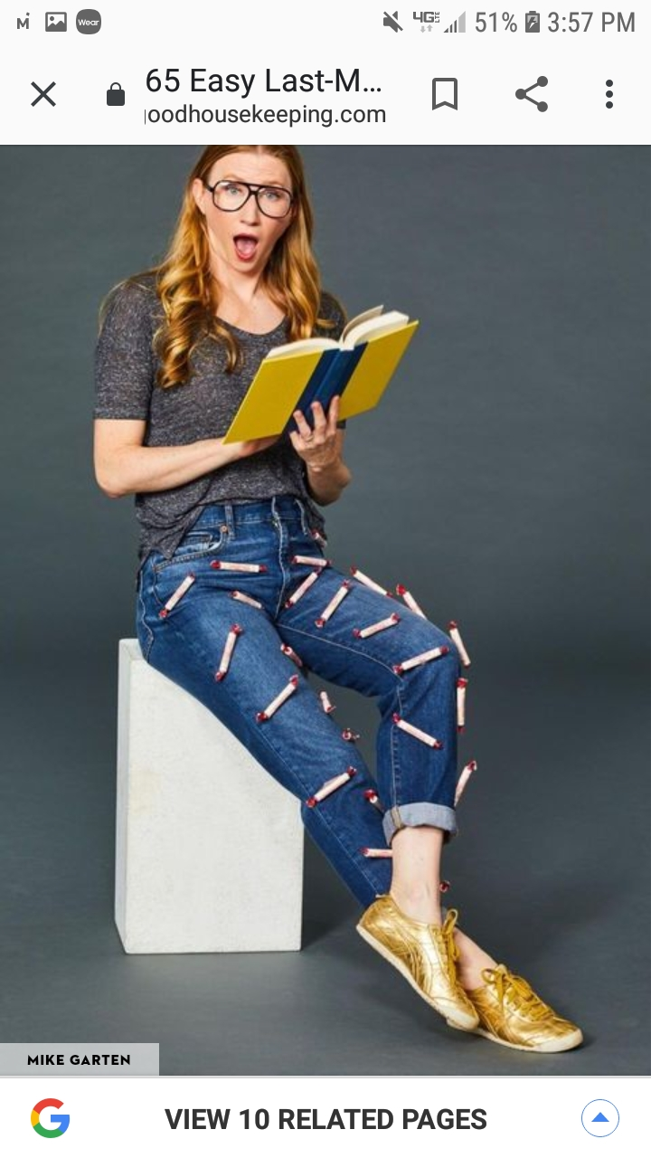

COMPLETE INSTRUCTIONS CAN BE FOUND AT:
WWW.GOODHOUSEKEEPING.COM

