RICHMOND RECREATION
DIY
DOG TAG

SUPPLIES:
-SHRINKY DINK PRINTABLE PLASTIC SHEETS
-REGULAR OR DECORATIVE EDGE SCISSORS
-HOLE PUNCH

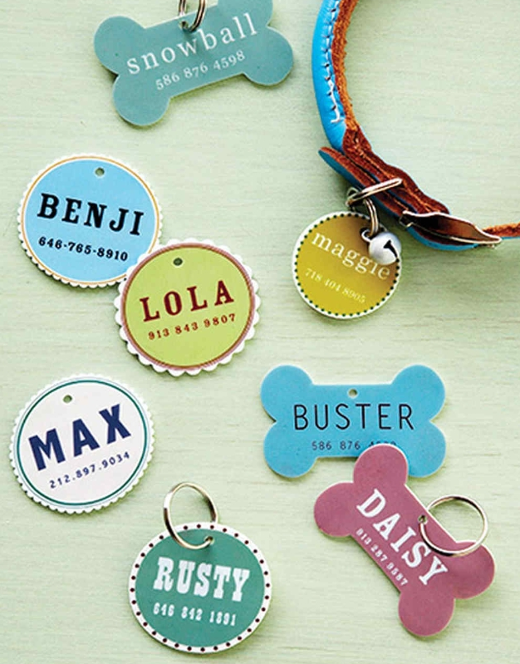

COMPLETE INSTRUCTIONS CAN BE FOUND AT:
WWW.MARTHASTEWART.COM

