RICHMOND RECREATION
HOW TO MAKE:
SALT DOUGH EASTER EGGS
SUPPLY LIST:
A BATCH OR 2 OF SALT DOUGH
ROLLING PIN
RULER
EGG SHAPE CUTTER/OR TRACE BY HAND
SPATULA
STRAW
PARCHEMENT PAPER FOR BAKING SHEET
PAINT/CLEAR COAT SEALER
RIBBON

SALT DOUGH:
1 CUP FLOUR
½ CUP SALT
½ CUP OF WATER
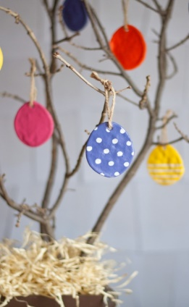
INFO.FOUND ON: WWW.DESIGNMOM.COM

