RICHMOND RECREATION
CEREAL BOX AQUARIUM
SUPPLIES:
-1 CEREAL BOX
-CONSTRUCTION PAPER
-STRING
-GLUE
-SCISSORS
-SHELLS/SAND/GOOGLY EYES OPTIONAL
-FISH TEMPLATE

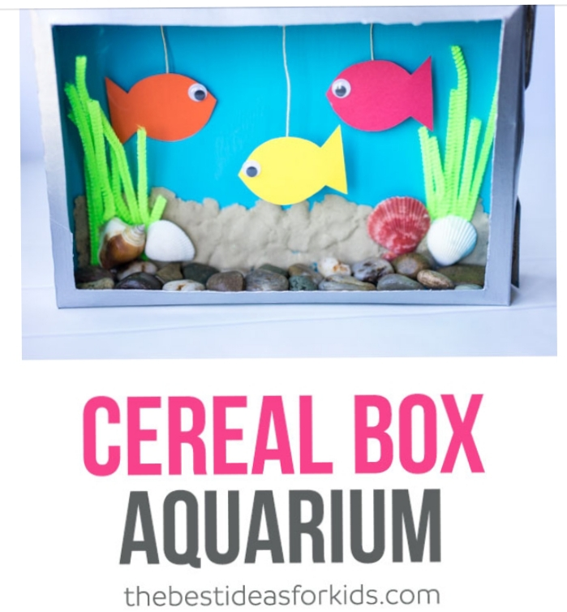
COMPLETE INSTRUCTIONS CAN BE FOUND AT:
WWW.THEBESTIDEASFORKIDS.COM

