RICHMOND RECREATION
MINI FRAMED ART
SUPPLIES:
-GLUE
-PAINT
-POPSICLE STICKS
-STRING OR RIBBON
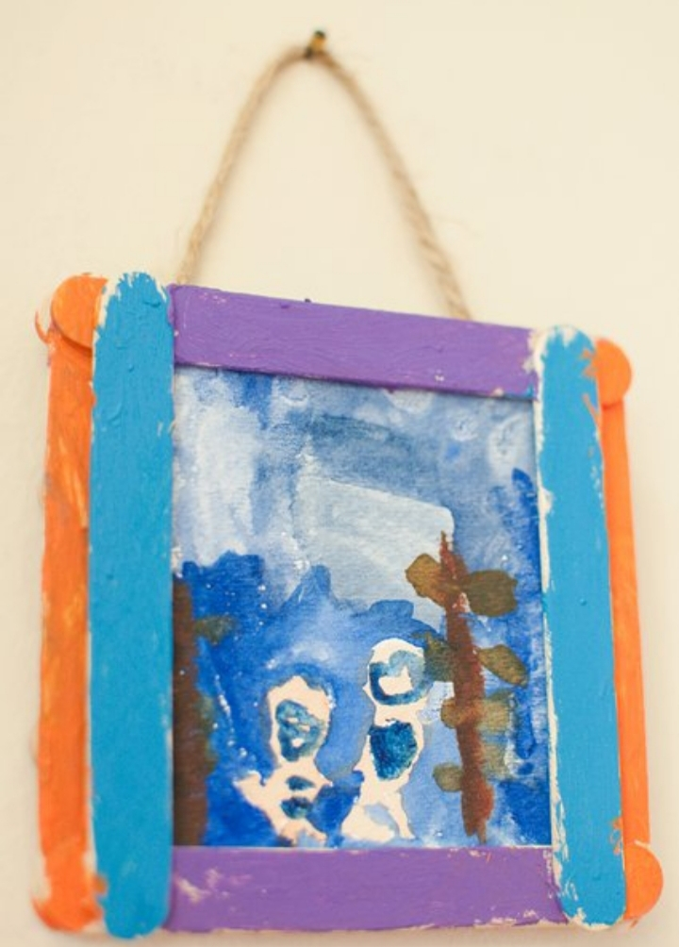
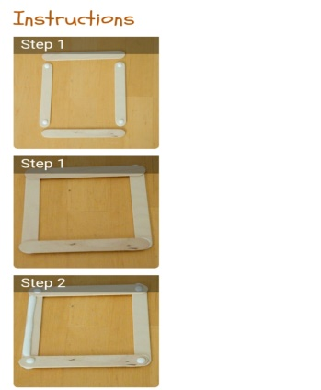
INSTRUCTIONS:
-GLUE STICKS AS SHOWN & ALLOW TO DRY
-PAINT FRAME
-CREATE SMALL PIECE OF ARTWORK TO PLACE IN FRAME
-ATTACH STRING OR RIBBON TO FRAME TO HANGE

MORE PROJECTS CAN BE FOUND AT: WWW.BROOGLY.COM

