RICHMOND RECREATION
HOMEMADE WENDY’S FROSTYS
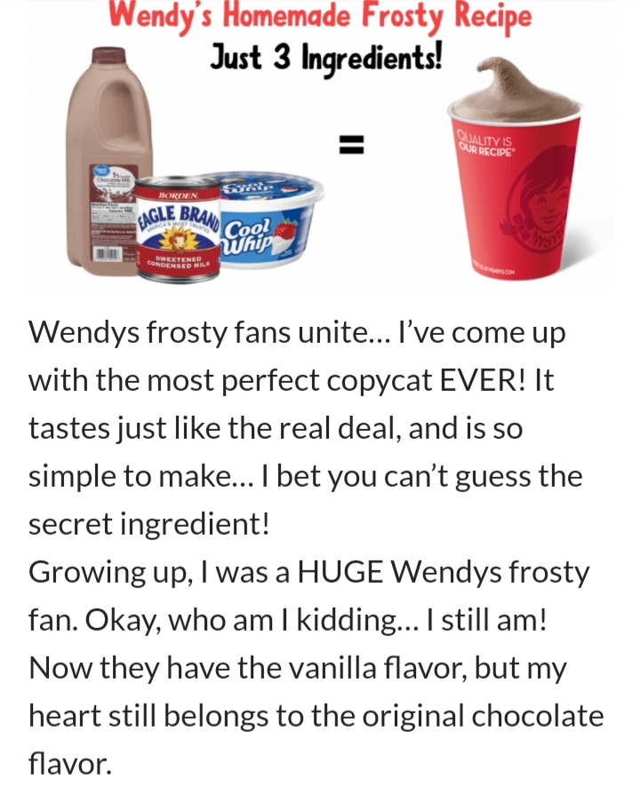
COMPLETE INSTRUCTIONS
CAN BE FOUND AT:
WWW.EASYRECIPES105.COM

