RICHMOND RECREATION
GNOME PUMPKINS

SUPPLIES:
-PUMPKIN REAL OR FAUX
-FABRIC FOR HAT
-GLUE
-YARN
-WOOEN BEAD FOR NOSE

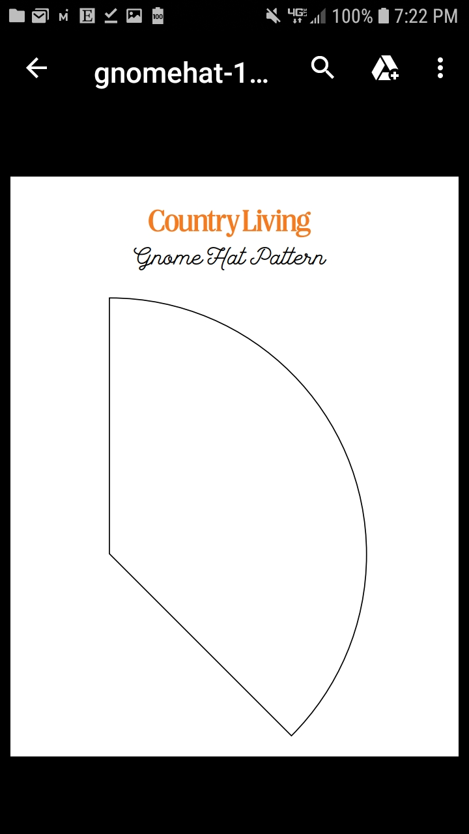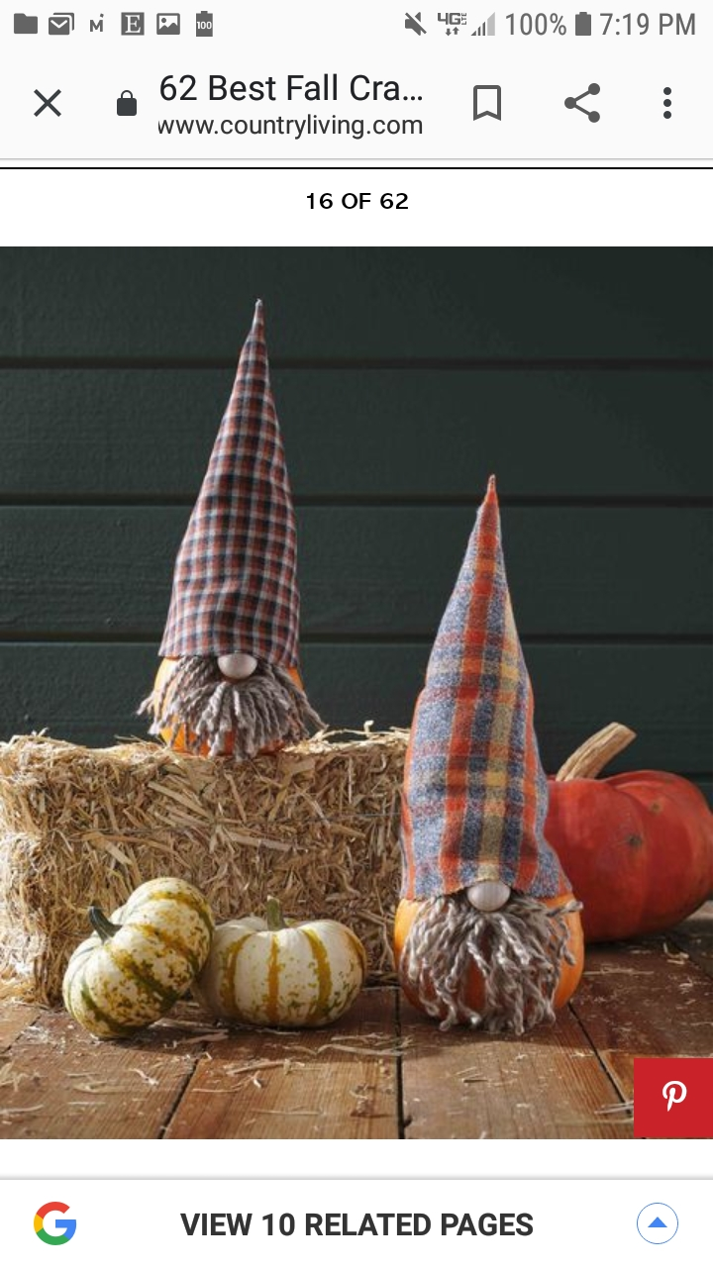

MORE DETAILED INSTRUCTIONS CAN BE FOUND AT:
WWW.COUNTRYLIVING.COM

