RICHMOND RECREATION
HANDY DANDY UNICORNS
SUPPLIES:
-WHITE PAPER
-PAINT
-YARN
-GLUE
-BLACK MARKER
-GOLD OR BRONZE MARKER FOR HORN

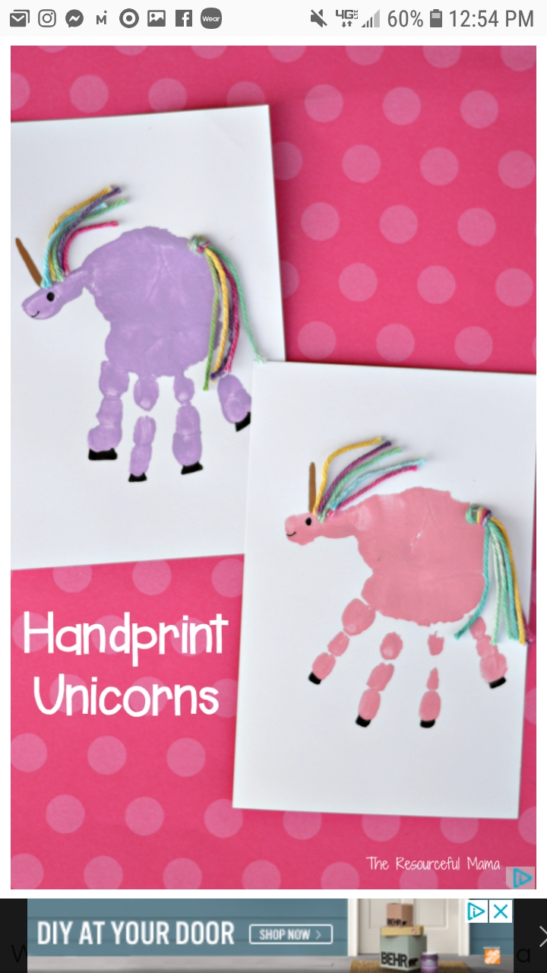

FOR MORE INFO.ON THIS CRAFT GO TO:
RESOURCEFUL MAMA’S

