RICHMOND RECREATION
MAKE AN ICE CREAM CONE
SUPPLIES:
-CONSTRUCTION PAPER
-MARKERS
-TAPE OR GLUE
-SCISSORS
-POM POMS
-THREAD & NEEDLE (FOR ADULTS TO USE)

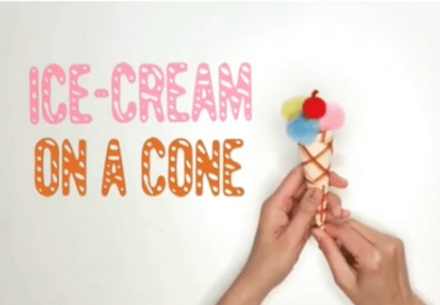

FOR FULL
INSTRUCTIONS
WATCH THE VIDEO
ON
YOU TUBE
AT
PIGGIE STEPS

