RICHMOND RECREATION
GLOW IN THE DARK
JELLYFISH
SUPPLIES:
-HEAVY WEIGHT PAPER BOWLS
-WHITE YARN
-GLOW IN THE DARK PAINT
-PAINT BRUSHES
-SCISSORS
-ZIPPER SANDWICH BAGS
-SKEWER OR SHARP PENCIL (FOR ADULTS TO USE)

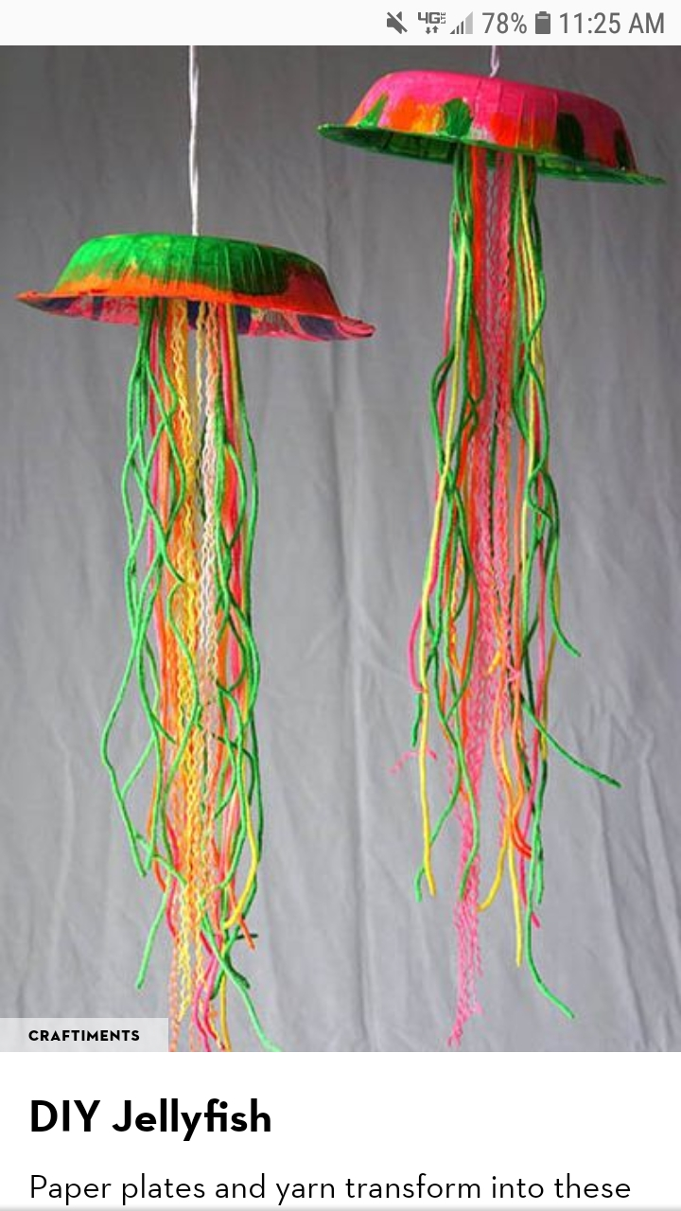

DETAILED INSTRUCTIONS
CAN BE FOUND AT:
WWW.CRAFTIMENTS.COM

