RICHMOND RECREATION
LAWN TWISTER
SUPPLIES:
-SOME SPACE IN YOUR YARD
-SPRAY PAINT OR YOU CAN USE CHALK PAINT
-SPINNER WHICH YOU CAN USE THE 1 FROM THE GAME OR CREATE YOUR OWN OUT OF CARDBOARD

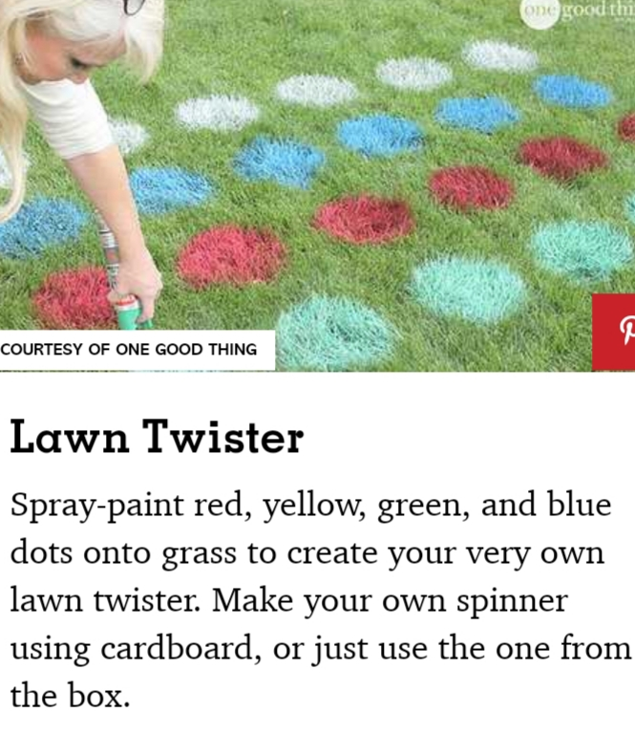
SPINNER DIRECTIONS:
CUT OUT THE SPINNER FROM CARDBOARD. PLACE THE PAPER CLIP IN THE CENTER OF IT. PLACE THE PENCIL POINT IN THE CENTER OF THE SPINNER AND PUSH THE END OF THE PAPER CLIP SO IT REST BEHIND THE PENCIL POINT AND SPIN.
