RICHMOND RECREATION
DIY FALLING LEAVES GARLAND

SUPPLIES:
-ARTIFICL LEAVES (CAN BE FOUND AT DOLLAR TREE STORES)
-RIBBON
-PAINT BRUSH
-GLUE
-GLITTER
-HOLE PUNCH

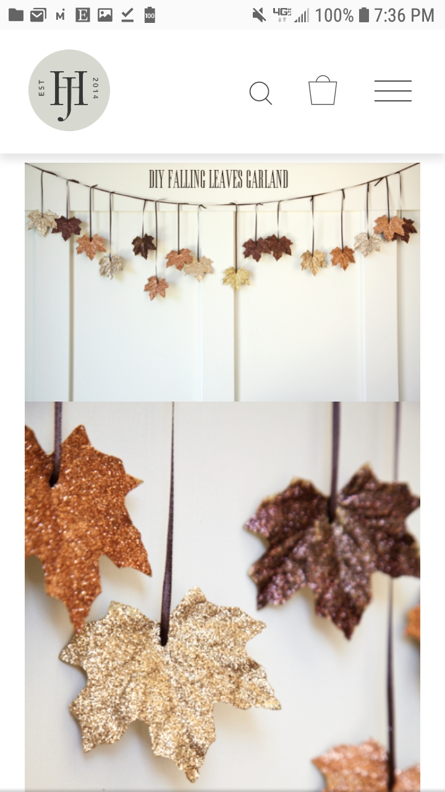

MORE DETAILED INSTRUCTIONS CAN BE FOUND AT:
WWW.COUNTRYLIVING.COM

