RICHMOND RECREATION
MOSAIC LIZARD
SUPPLIES:
-GLUE

-COLORED PAPER
-GOOGLY EYES (OPTIONAL) OR USE MARKER TO DRAW EYES ON
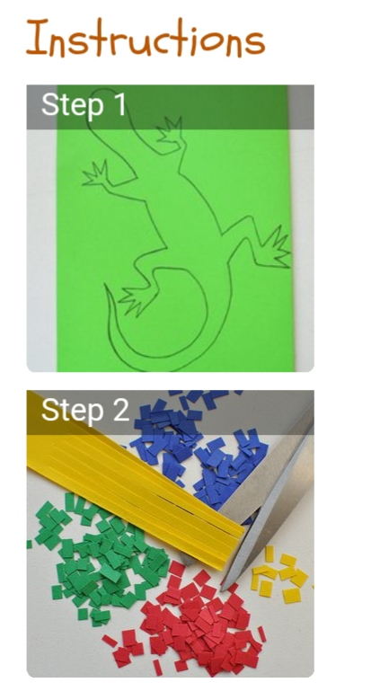
INSTRUCTIONS:
-DRAW LIZARD SHAPE & CUT OUT LIZARD SHAPE
-PREP SQUARES OF COLORED PAPER
-SPREAD GLUE OVER LIZARD & THEN SPRINKLE THE SQUARES OVER THE GLUE ON LIZARD
-GLUE EYES ON OR USE MARKER TO DRAW EYES ON
-ONCE DRY YOU MAY WANT TO TRIM THE HANG OVER ON EDGES
MORE PROJECTS CAN BE FOUND AT: WWW.BROOGLY.COM

