RICHMOND RECREATION

TISSUE BOX MONSTER
SUPPLIES:
-TISSUE BOX
-PAINT OR MARKERS
-GLUE
-WHITE PAPER
-SCISSORS
-GOOGLY EYES/POPSICLE STICK/POM POMS ARE OPTIONAL

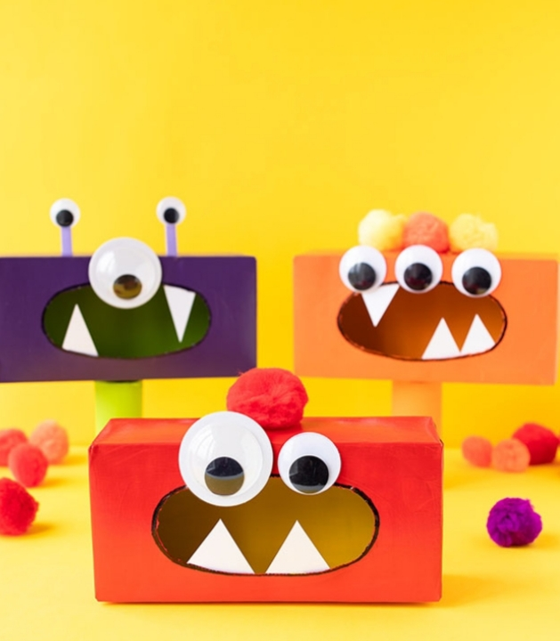

COMPLETE INSTRUCTIONS CAN BE FOUND AT:
WWW.THEBESTIDEASFORKIDS.COM

