RICHMOND RECREATION
BUILD A PAPER OCTOPUS
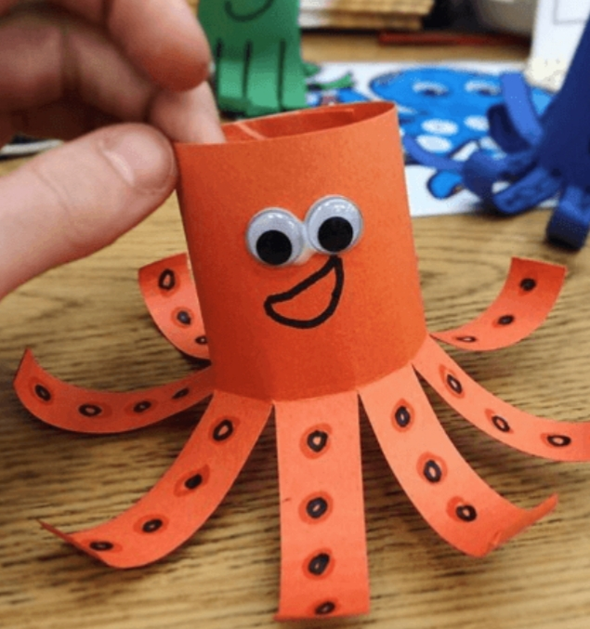
SUPPLIES:
-CONSTRUCTION PAPER
-MARKERS
-TAPE
-GOOGLY EYES OPTIONAL

DIRECTIONS:

-CUT A RECTANGLE OUT OF CONSTRUCTION PAPER

-FOLD IT IN HALF LENGTH WISE TO MAKE A CREASE

-CUT SNIPS OF THE BOTTOM HALF OF THE PAPER, NOT GOING ABOVE THE CREASE YOU JUST FOLDED

-BRING EDGES TOGETHER AND TAPE THEM TOGETHER TO MAKE THE OCTOPUS

-DECORATE OCTOPUS AND YOU CAN ROLL EACH STRIP/LEG WITH A PENCIL SO IT WILL CURL LIKE THE ONE SHOWN

