RICHMOND RECREATION
EASTER CRAFT EDITION:
PAPER PLATE EASTER BUNNY
SUPPLIES:
-PIPE CLEANER OR YARN
-POM POMS/POM POMS CAN BE MADE FROM YARN TOO
-GOOGLY EYES/OR USE MARKER TO DRAW EYES ON
-CONSTRUCTION PAPER
-PAPER PLATES

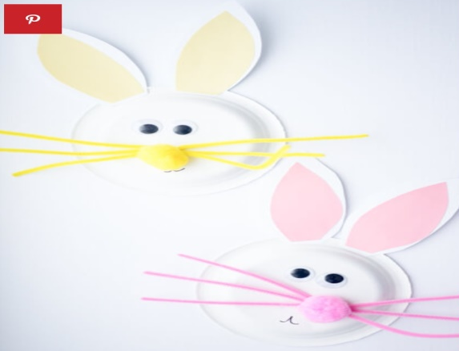

ONLINE VIDEOS OF ALL CRAFTS SHOWN CAN BE FOUND AT: WWW.THEBESTIDEASFORKIDS.COM

