RICHMOND RECREATION
SHARK PAPER TUBE BINOCULARS
SUPPLIES:
-2 TOILET PAPER ROLLS
-SCISSORS OR CRAFT KNIFE USED BY AN ADULT
-CEREAL BOX CARDBOARD
-PAINT & BRUSH
-TAPE
-MARKER
-HOLE PUNCHER
-STRING
-BEADS
-GOOGLY EYES

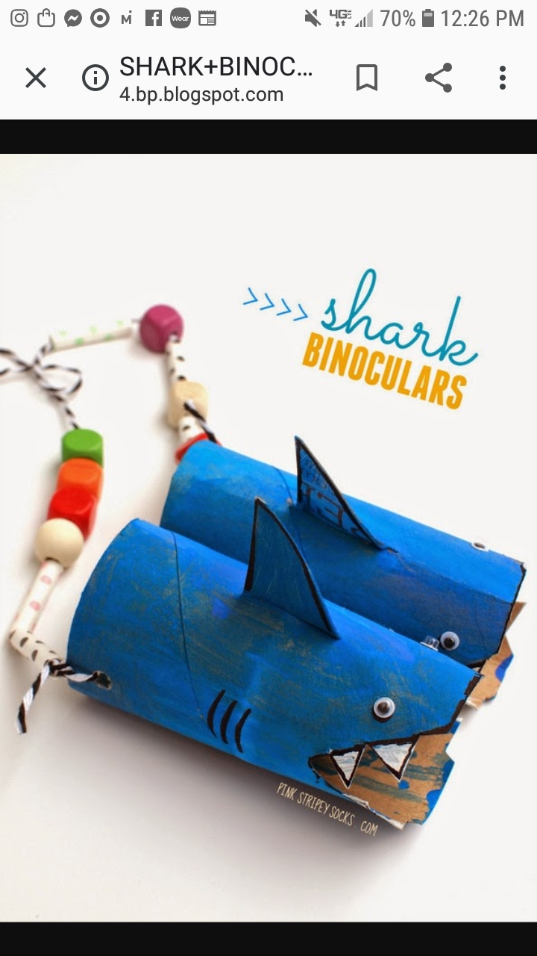
FOR COMPLETE INSTRUCTIONS GO TO:
WWW.PINKSTRIPEYSOCKS.COM

