RICHMOND RECREATION
EASTER CRAFT EDITION:
PASTA NOODLE EASTER EGGS
SUPPLIES:
-ASSORTED PASTA NOODLES
-CARDBOARD
-PAINT
-GLUE
-USE EGG TEMPLATE FROM THE YARN EGG CRAFT

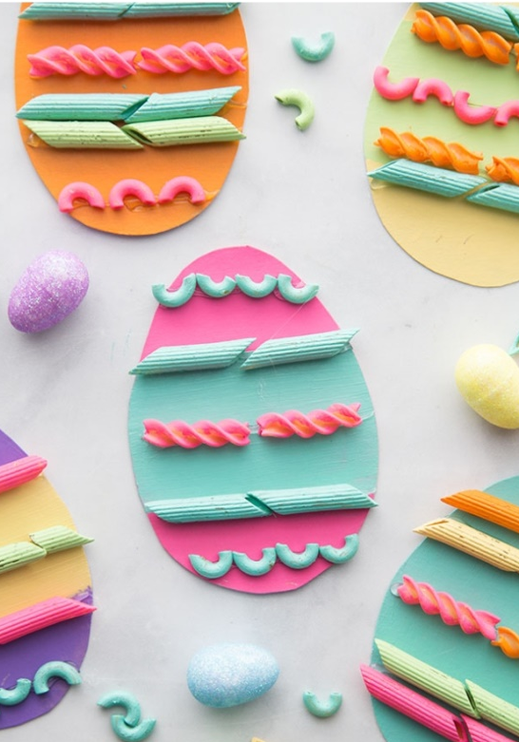

0NLINE VIDEOS OF ALL CRAFTS SHOWN CAN BE FOUND AT: WWW.THEBESTIDEASFORKIDS.COM

