RICHMOND RECREATION
POPSICLE STICK PENCIL CUP
SUPPLIES:
-GLUE
-MARKERS
-POPSICLE STICKS
-PAINT
-PAINTBRUSH
-TIN CAN

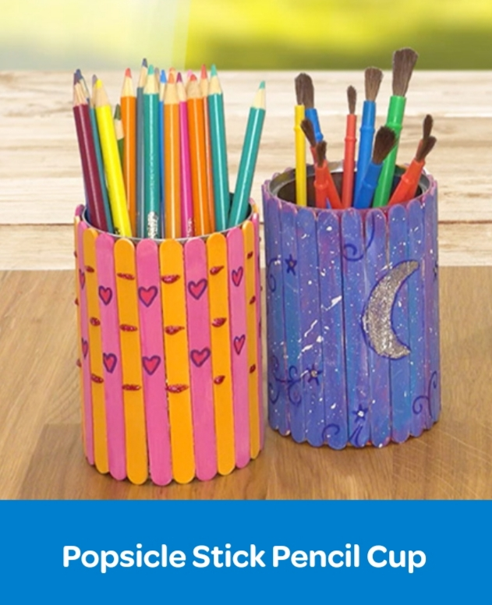

COMPLETE INSTRUCTIONS CAN BE FOUND AT:
WWW.CRAYOLA.COM
UNDER TRENDING CRAFTS

