RICHMOND RECREATION
PAPER PLATE PIGGIES
SUPPLIES:
-2 PAPER PLATES
-PINK CONSTRUCTION PAPER OR WHATEVER COLOR YOU WANT TO MAKE YOUR PIGGIE
-PAINT
-PIPE CLEANER & GOOGLY EYES ARE OPTIONAL
(YOU CAN USE MARKER FOR EYES AND PAPER FOR TAIL)
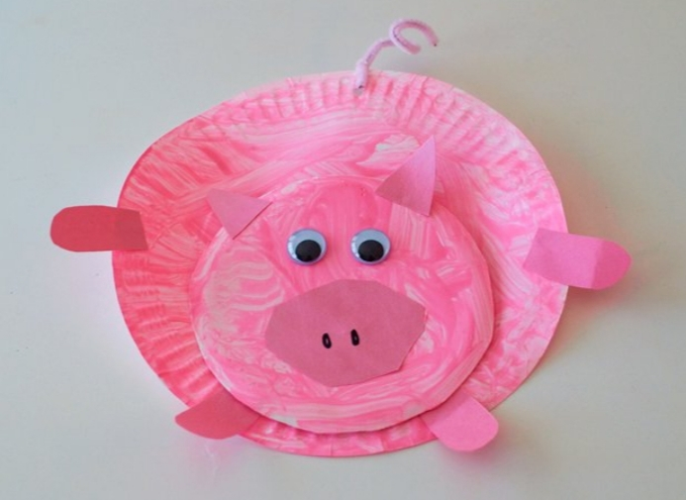
INSTRUCTIONS:
-PAINT BOTH PAPER PLATES & LET DRY
-ADULTS CAN CUT THE EDGE OFF 1 OF THE PAPER PLATES TO CREATE A SMALLER CIRCLE, CUT OVAL FOR NOSE SHAPE, 4 LEGS & 2 EARS FROM PAPER. EARS CAN BE CUT INTO TRIANGLES.
-ADULTS CAN HELP GLUE NOSE, EYES & EARS TO SMALLER CIRCLE. NOW GLUE HEAD TO LARGE PLATE. PUNCH HOLE IN TOP OF THE LARGE PLATE, THREAD PIPE CLEANER THROUGH HOLE & TWIST TO SECURE & BEND INTO CURLY SHAPE FOR TAIL OR JUST CUT A TAIL OUT OF THE CONSTRUCTION PAPER & GLUE IT.

MORE PROJECTS CAN BE FOUND AT:
WWW.BROOGLY.COM

