RICHMOND RECREATION
HOME DEPOT
CREATE YOUR OWN PLAYHOUSE
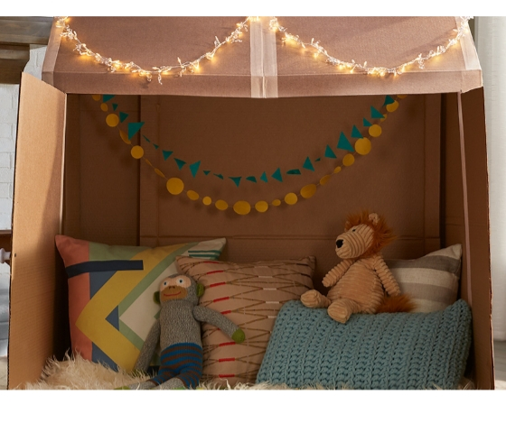
SUPPLIES:
-BOXES
-MASKING TAPE
-DUCT TAPE
-MARKERS/PENS
-ROPE
-SCISSORS OR CUTTING KNIFE FOR AN ADULT TO USE

COMPLETE INSTRUCTIONS ARE FOUND ON HOME DEPOT SITE.

FOR MORE INFO. GO TO:
WWW.HOMEDEPOT.COM
THEN GO TO DIY PROJECTS SCROLL DOWN TO ACTIVITIES FOR KIDS

