RICHMOND RECREATION
MAKE A POPSICLE BANNER
SUPPLIES:
-WHITE PAPER
-POPSICLE STICK
-MARKERS FOR DECORATING
-TAPE OR GLUE
-SCISSORS
-STRING
-A HOLE PUNCHER OR HAVE AN ADULT POKE A PENCIL FOR THE HOLES

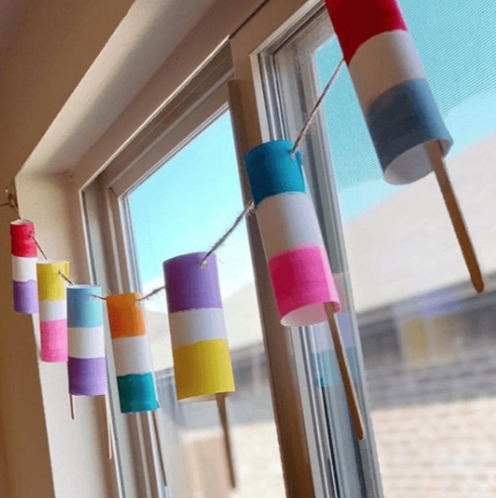

DIRECTIONS:
-CUT THE PAPER INTO RECTANGLES

-COLOR STRIPES ONTO THE WHITE PAPER (AS SHOWN IN PICTURE)

-ROLL THE PAPER INTO A TUBE SHAPE, GLUE OR TAPE THE ENDS TOGETHER

-TAPE OR GLUE THE STICKS INTO EACH POPSICLE

-ADD THE HOLES TO THE TOP OF THE POPSICLES AS SHOWN

-THEN STRING THE POPSICLES ONTO THE STRING AND YOU NOW HAVE A BANNER

