RICHMOND RECREATION
MAKE A POPSICLE
SUPPLIES:
-CONSTRUCTION PAPER OR FELT OR FOAM
-POPSICLE STICK
-MARKERS FOR DECORATING
-TAPE OR GLUE
-SCISSORS
-POM POMS/BEADS/GLITTER GLUE (OPTIONAL FOR DECORATING)

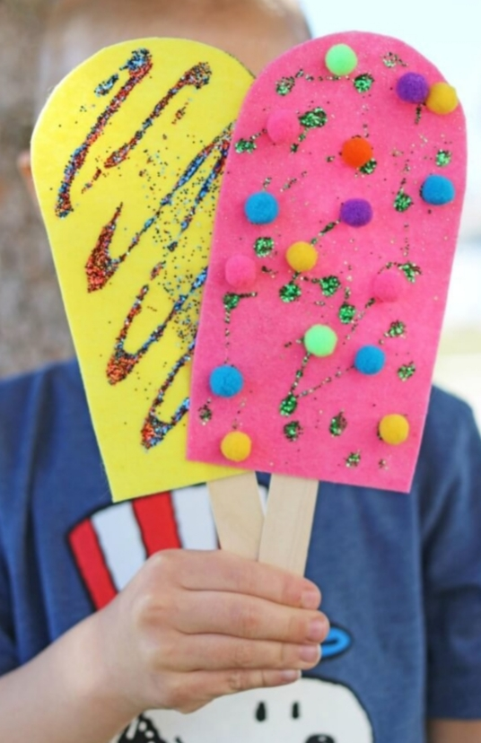

DIRECTIONS:
-CUT THE PAPER/FELT OR FORM IN A RECTANGLE SHAPE AND ROUND THE 1 END TO FORM THE POPSICLE

-DECORATE THE POPSICLE

-GLUE OR TAPE THE POPSICLE STICK TO THE BACK OF THE PAPER/FELT OR FOAM

