RICHMOND RECREATION
POOL NOODLE RACE TRACK

SUPPLIES:
-1 POOL NOODLE
-MARKERS
-PAPER
-SCISSORS
-TOOTHPICKS
-GLUE OR TAPE
-SMALL RACE CARS OR TRUCKS

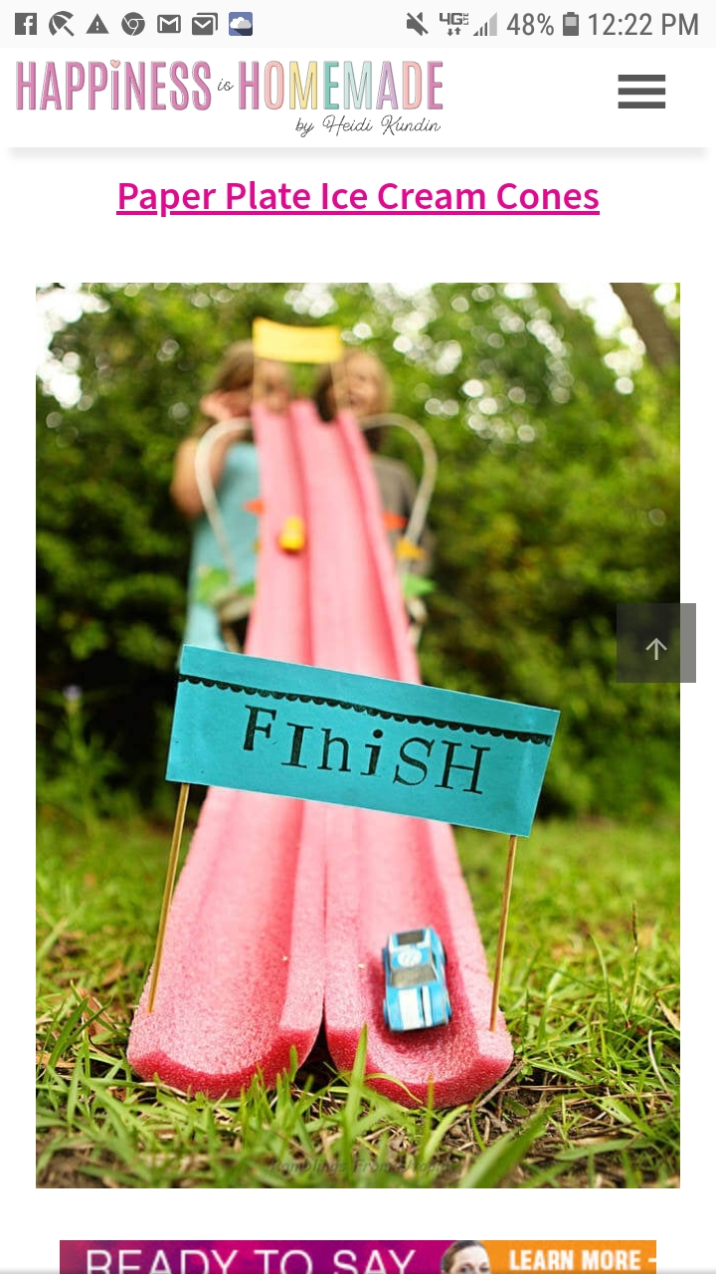

DIRECTIONS:
-CUT POOL NOODLE IN HALF FOR THE TRACK
-USE THE PAPER & MARKERS TO CREATE A START AND FINISH LINE
-GLUE OR TAPE THE START AND FINISH LINE TO THE TOOTHPICKS, PRESS THEM INTO THE NOODLE
AND LET THE RACES BEGIN!!

