RICHMOND RECREATION
SHARK FIN HAT
SUPPLIES:
-CONSTRUCTION PAPER
-CARDSTOCK PAPER
-TAPE
-SCISSORS

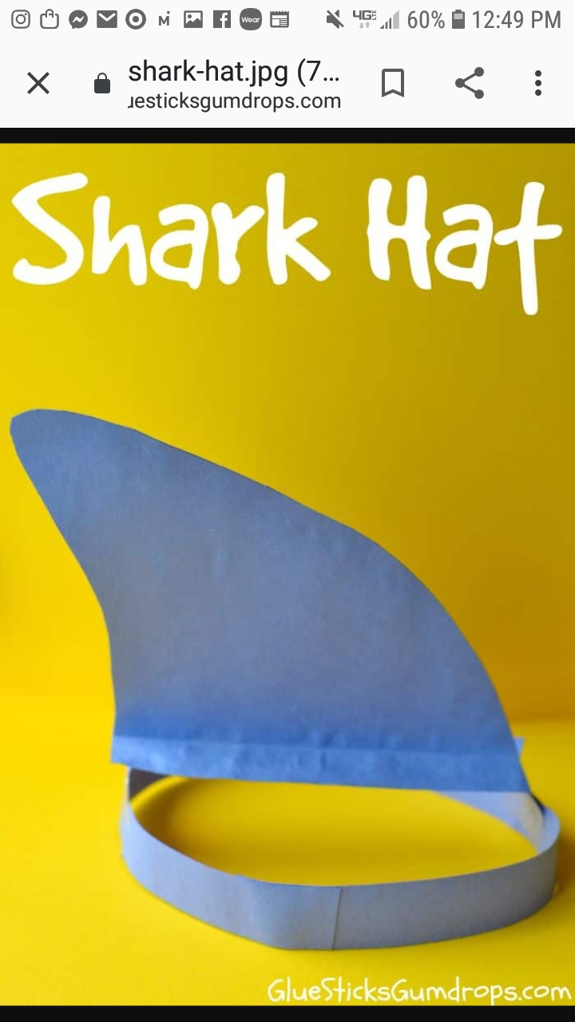

FOR MORE INFO. GO TO:
WWW.GLUESTICKSGUMDROPS.COM

