RICHMOND RECREATION
SKELETON PAPER PLATES
SUPPLIES:
-PAPER PLATES
-BLACK MARKER
-SCISSORS
-STRING
-HOLE PUNCH

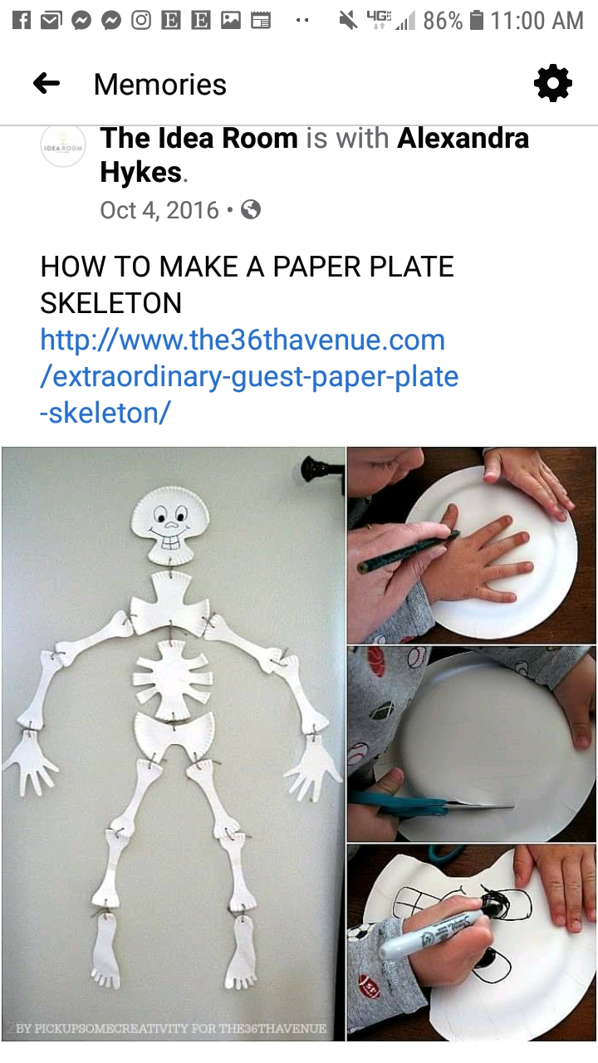

COMPLETE INSTRUCTIONS CAN BE FOUND AT:
HTTP://WWW.THE36THAVENURE.COM/EXTRAORIDINARY-GUEST-PAPER-PLATE-SKELETON

